Prepared: Aida Zace, Xheisiana Hida, Francesko Ohri

Kindergarten Management System Design

# Requirements Table

**Functional Requirements**

|  |  |  |  |  |
| --- | --- | --- | --- | --- |
| Req# | Requirement | Description | Coments | Rate |
| FR_01 | Child Records Management | Capture and maintain detailed profiles for each child (personal details, medical history, enrollment). | Essential for personalized education. | High |
| FR_02 | Attendance Tracking | Record daily attendance for children and staff, and generate summary reports. | Critical for operational oversight. | High |
| FR_03 | Staff Management | Manage staff details including roles, schedules, and performance for teachers, sanitars, and chefs. | Integrates all staff functions. | High |
| FR_04 | Meal Planning & Dietary Management | Plan menus, handle dietary restrictions, and manage meal inventories. | Key for ensuring child nutrition and safety. | High |
| FR_05 | Parent Communication | Facilitate communication with parents via notifications, updates, and progress reports. | Vital for transparency and engagement. | High |
| FR_06 | Reporting and Analytics | Generate detailed reports on attendance, staff performance, and financial metrics for decision-making. | Supports compliance and strategic planning. | High |
| FR_07 | Event Management | Schedule and manage events (parent-teacher meetings, school holidays, class activities) with notifications. | Enhances community involvement. | Medium |
| FR_08 | Secure Login and Access Control | Provide a secure, role-based login system to protect sensitive data. | Critical for data privacy and protection. | High |
| FR_09 | Notifications & Alerts | Send timely notifications and alerts regarding system updates and emergencies. | Improves real-time responsiveness. | Medium |
| FR_10 | System Integration & Maintenance | Enable integration with third-party applications and provide tools for system maintenance. | Enhances overall system stability. | Medium |

# Non-Functional Requirements

Non-functional requirements (NFRs) define the system attributes such as security, reliability, maintainability, performance, and usability. Unlike functional requirements (FRs), which describe what the system should do, NFRs define how the system performs under various conditions. These requirements are crucial for the overall usability, stability, and efficiency of the solution.

**Product Requirements**

**1. Security Requirements**

* All sensitive data (children’s records, medical data, staff details) must be encrypted both at rest and during transmission.
* Implement role-based access control for Admin, Teacher, Sanitar, Chef, and Parent roles.
* Support for session timeout and secure authentication (e.g., hashed passwords, CAPTCHA for login).
* Use HTTPS protocols for all data exchange.

**2. Performance Requirements**

* The system should respond to user requests within 2 seconds under normal conditions.
* Maintain 99.9% uptime during working hours (Mon–Fri, 07:00–18:00).
* Generate attendance and meal reports within 5 seconds of user request.

**3. Reliability Requirements**

* System must support automated daily backups of all databases.
* Implement failover strategies to ensure continued service during server failures.
* Support for data recovery within 1 hour of an incident.

**Organizational Requirements**

**1. Training & Documentation**

* User manuals tailored for each role (Admin, Teacher, etc.).
* Hands-on training sessions for staff, including simulations for emergency alerts and event scheduling.

**2. Change Management**

* Define a version control policy for updates and patches.
* Maintain a rollback mechanism in case of system update failure.

**Environmental Requirements**

**1. Technologies to be Used**

* Backend: Java using Spring Framework.
* Frontend: Java Swing or JavaFX; optionally, web technologies (HTML/CSS/JS) for parent portals.
* Database: MySQL (with XAMPP/phpMyAdmin for local dev).
* Build Tools: Maven or Gradle (for dependency management).

**2. Infrastructure & Hardware**

* Server: Quad-core CPU, 16GB RAM (recommended), SSD storage.
* Clients: Any machine with Java 11+, 4GB RAM minimum.
* Network: Wired or WiFi with at least 20 Mbps bandwidth.

**3. Software Dependencies**

* Java 11+, MySQL 8+, Spring Boot, Hibernate.
* IDEs: NetBeans or IntelliJ.
* Optional: JasperReports for report generation.

**4. Network Requirements**

* Secure internal LAN or VPN for administrative access.
* Protection through firewalls and anti-virus software.
* HTTPS for web-based communication.

**5. Data Storage and Management**

* Minimum 500GB of storage to handle media files and records.
* Backup strategy: Daily full backups, weekly cloud sync.

**6. Environmental Security**

* Controlled access to the server room.
* CCTV and physical security measures.
* Fire suppression and temperature/humidity control systems.

**7. Integration with External Systems**

* Support integration with:
  + Email services (e.g., Gmail SMTP) for parent notifications.
  + Google Calendar API for event synchronization.
  + Third-party SMS gateway for alerts.

**8. Scalability Testing**

* Load test to simulate up to 200 concurrent users.
* Test performance during peak hours (e.g., 7:00–8:00 check-in).

**9. Compliance Monitoring**

* Implement audit logs and monitoring tools to ensure:
  + Compliance with child safety and data privacy standards.
  + Alerts for any unauthorized access attempts.

**10. Usability Testing Environment**

* Include parents and staff in testing groups.
* Conduct bi-monthly UI/UX reviews.

**11. Training Facilities**

* Provide a sandbox environment for staff training.
* Use training videos and workshops.

**External Requirements**

**1. Integration**

* Ability to connect with:
  + Government databases (e.g., for vaccination status).
  + Emergency services via alert API (optional future feature).

**2. Regulatory Compliance**

* Adherence to Albanian data protection laws (compatible with GDPR principles).
* Compliant with health and safety guidelines for educational institutions.

**Ethical Requirements**

* Equal access for all children regardless of background.
* Transparent communication with parents regarding:
  + Food menus
  + Daily activities
  + Medical alerts or incidents
* Data used **only** for kindergarten operations, never shared without consent.

**Legislative Requirements**

* Compliance with:
  + Albanian Law on the Protection of Personal Data (Law no. 9887/2008).
  + Law on the Rights of the Child (Law no. 18/2017).
  + School regulations on reporting attendance, meals, and incidents.
* All data processing operations must follow the GDPR principles:
  + Lawfulness, fairness, and transparency
  + Data minimization and accuracy
  + Security and accountability

**Domain Requirements**

1. **Security and Access Control**
   * Different dashboards and access permissions based on user role.
2. **Audit and Logging**
   * Logs of login attempts, record modifications, and report generation.
3. **Automation**
   * Automated generation of meal schedules and alerts.
   * Auto-notification for low inventory or event reminders.
4. **Scalability**
   * Support for future expansion to multiple kindergarten branches.
5. **Accessibility**
   * Interface support in multiple languages (Albanian + English).
   * Accessibility for visually impaired users (WCAG compliance - optional).

# Stakeholders Table

|  |  |  |  |  |  |
| --- | --- | --- | --- | --- | --- |
| Stakeholders | Role/Responsibility | Importance | Influence | Interests/Positive Impacts | Concerns |
| Admin | System administration, managing user access & settings | High | High | System stability, smooth operations | Workload, system failures |
| Teachers | Using the system for educational management | High | Medium | Organized records, ease of access | System usability, training requirements |
| Sanitars | Maintaining hygiene and sanitation | Medium | Low | Efficient scheduling, clear work processes | System adaptation, workflow disruptions |
| Chefs | Managing meal preparation and dietary needs | Medium | Low | Efficient meal planning and tracking | Training on system usage |
| IT Support | Troubleshooting and maintaining technical systems | High | High | System stability, quick issue resolution | Resource constraints, workload |
| Parents | Monitoring students' progress and school-related info | High | Medium | Access to real-time updates, transparency | Data security, usability of parent interface |
| Accountant | Handling financial records and transactions | High | High | Financial accuracy, automated reports | Compliance issues, system bugs affecting data |
| Vendors | Supplying necessary goods and services | Medium | Low | Smooth transactions, timely payments | Order processing errors, delays |
| Auditors & Consultants | Ensuring compliance and system efficiency | High | Medium | Transparency, regulatory adherence | Limited access to critical data |
| Regulatory Authorities | Overseeing compliance with legal & educational standards | High | High | Adherence to regulations, accountability | Non-compliance, regulatory changes |
| Competitors | Competing in the same market space | Medium | High | Market insights, strategic positioning | Competitive disadvantages, innovation lag |

# User Stories

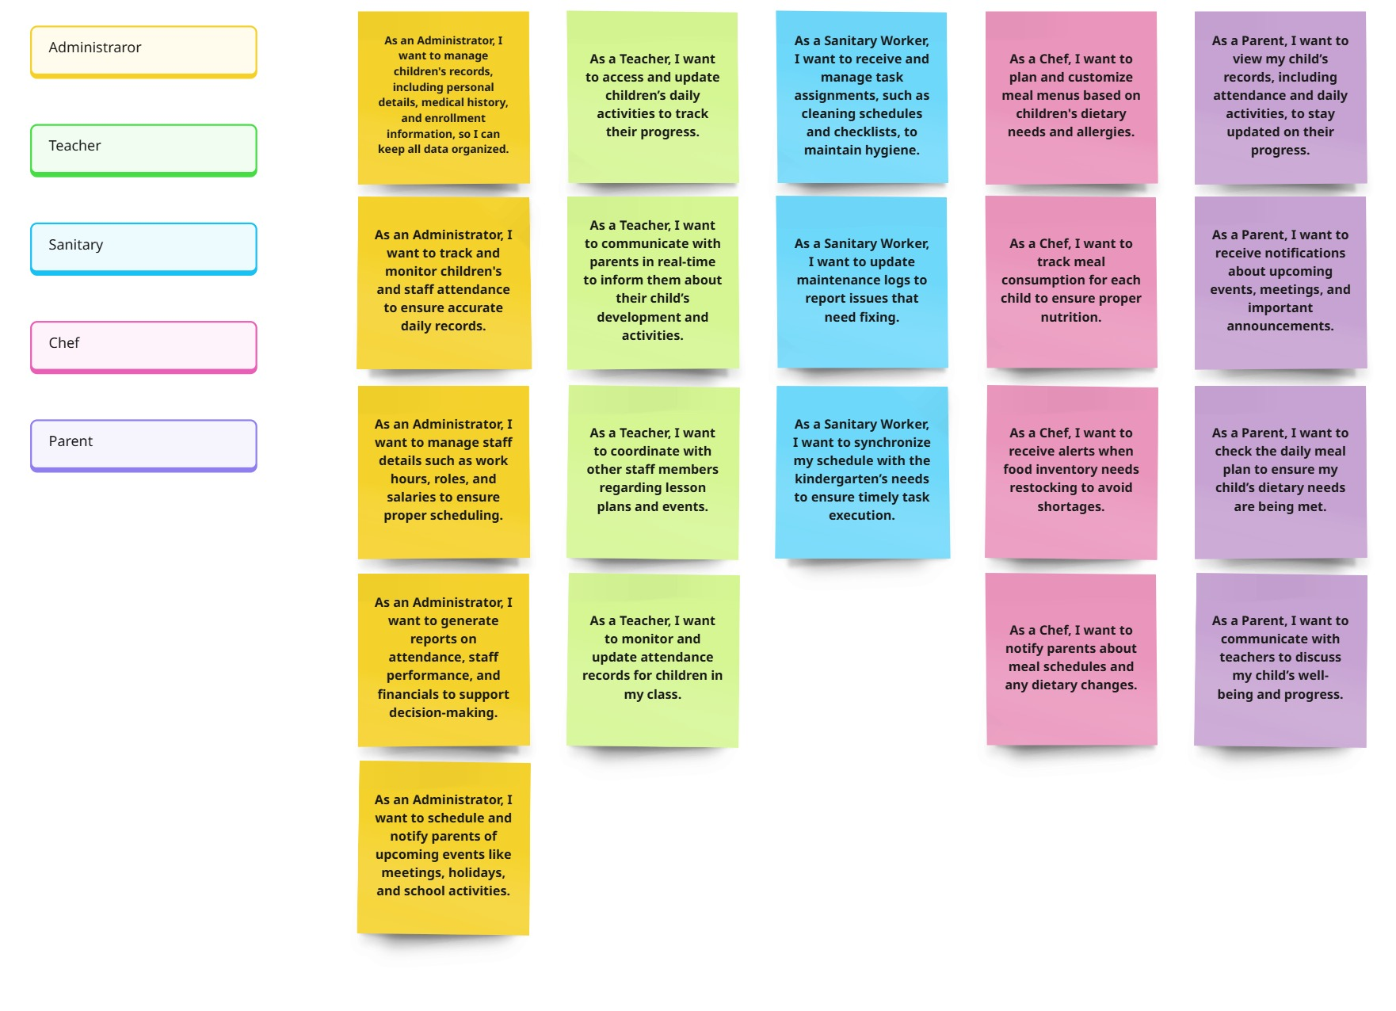

# Onion Diagram of Stakeholders

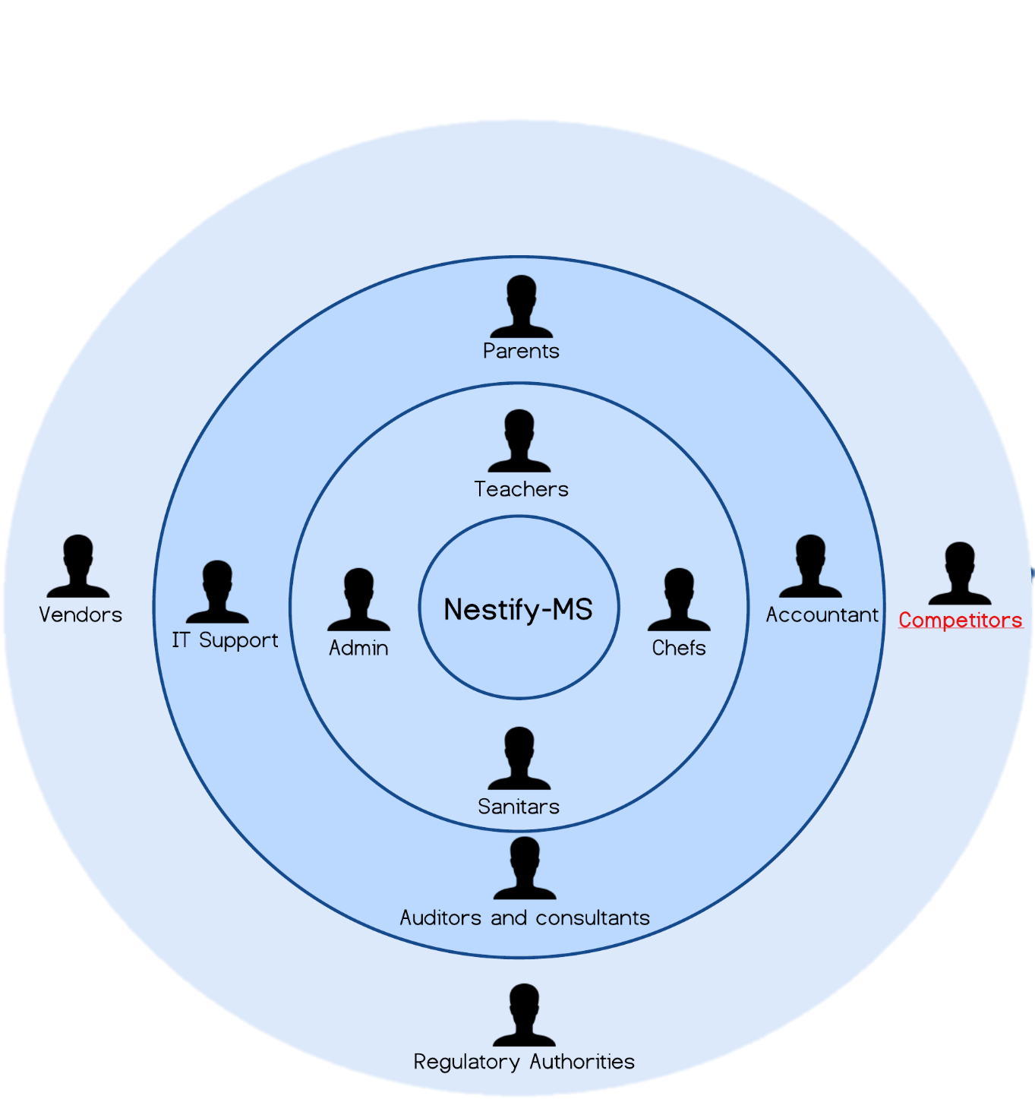

# Entity Relationship Diagram (ERD)

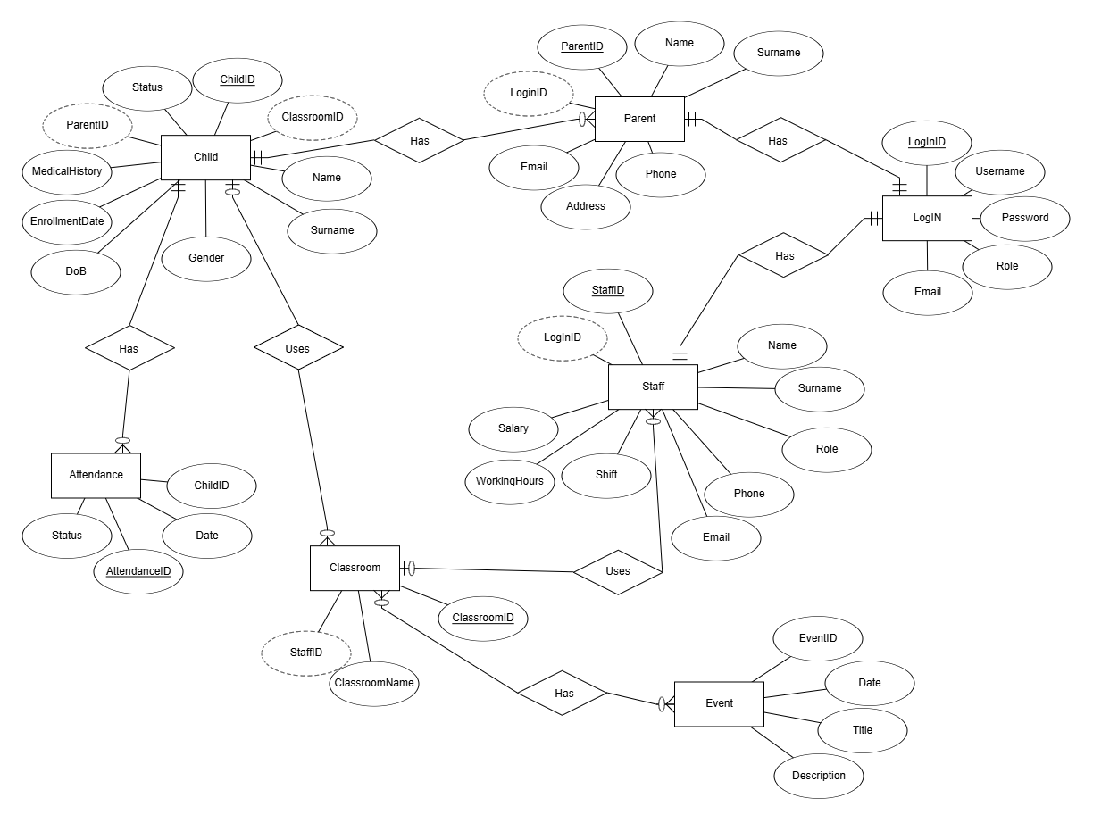

# BPMN

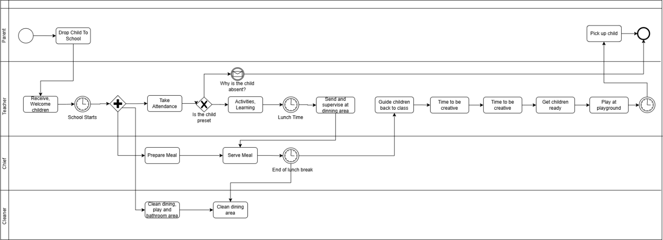BPMN1

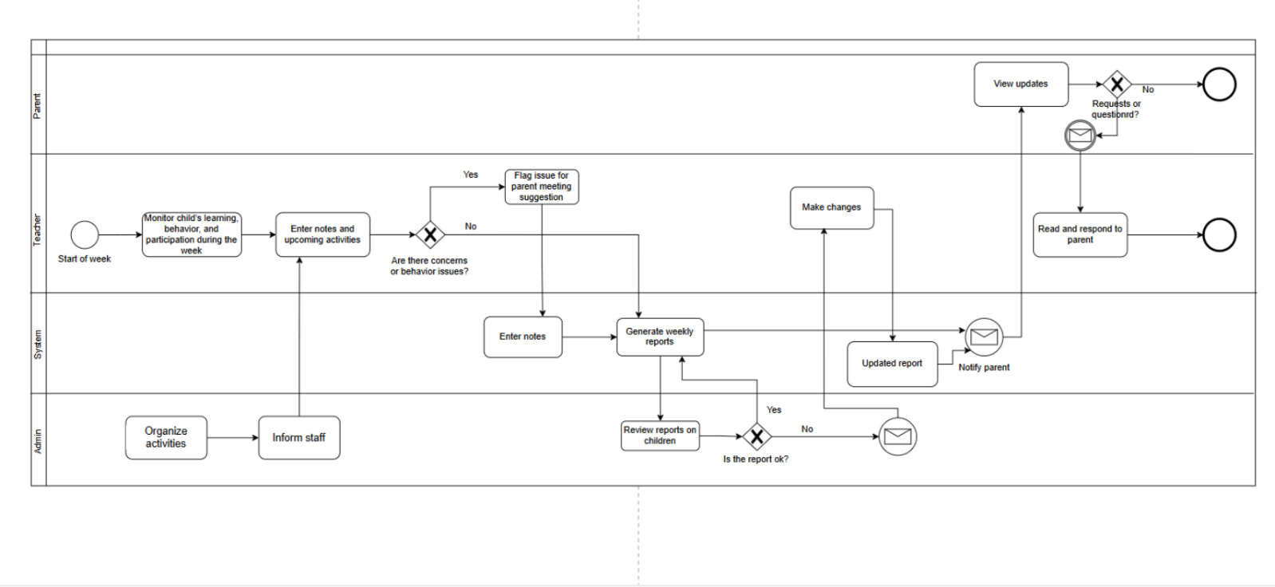BPMN2

BPMN3

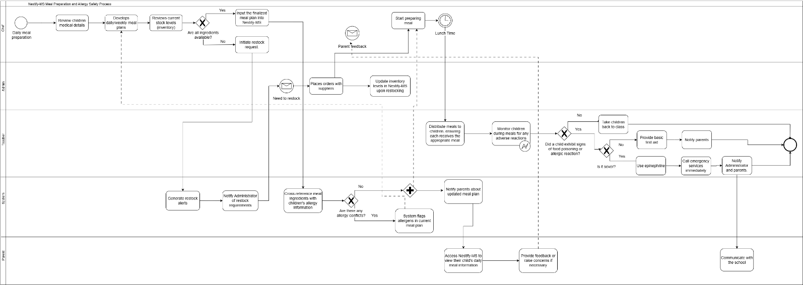

BPMN4

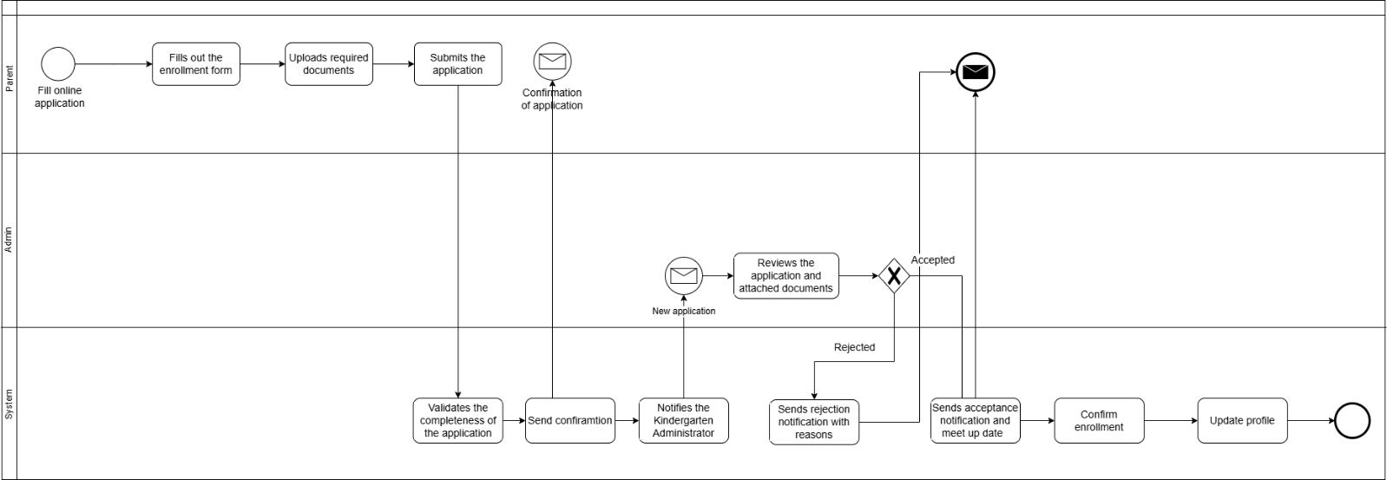

Data Flow Diagram (DFD)

**DFD LVL.0**

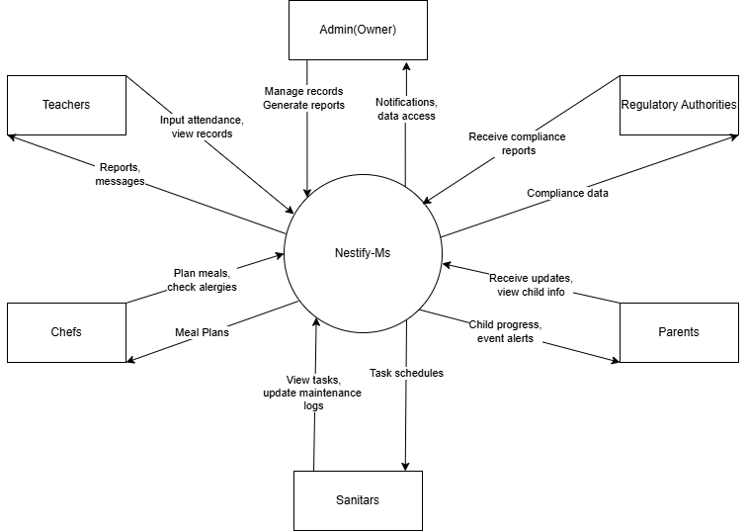

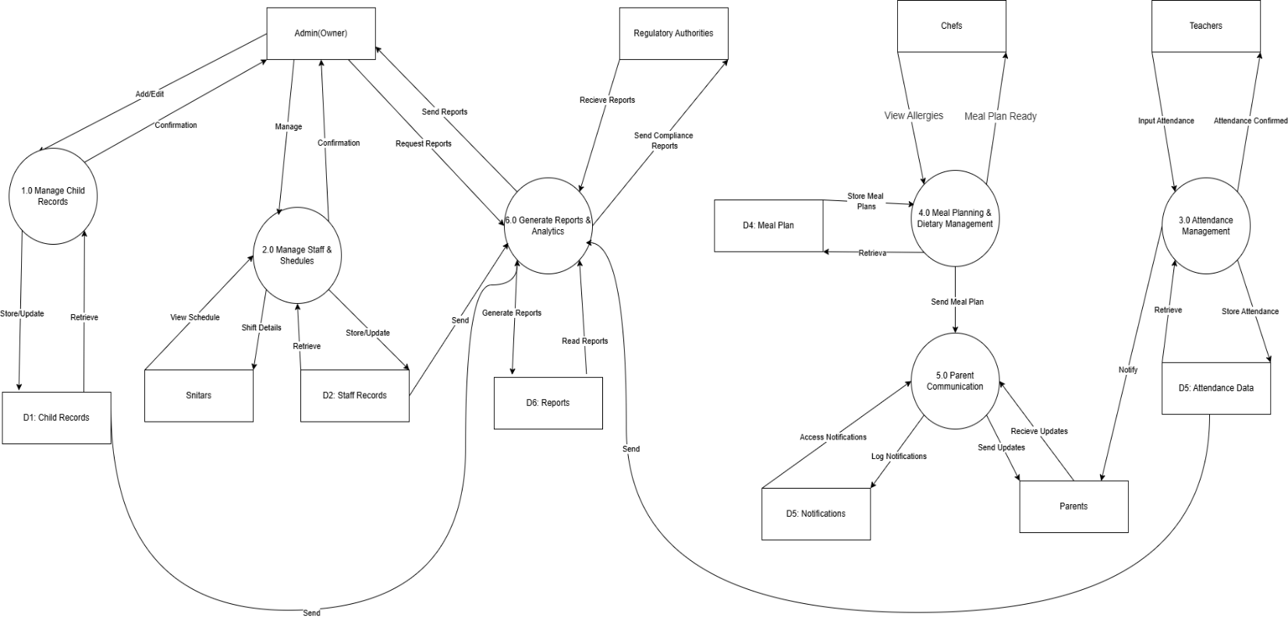**DFD LVL.1**

**DFD LVL.2**

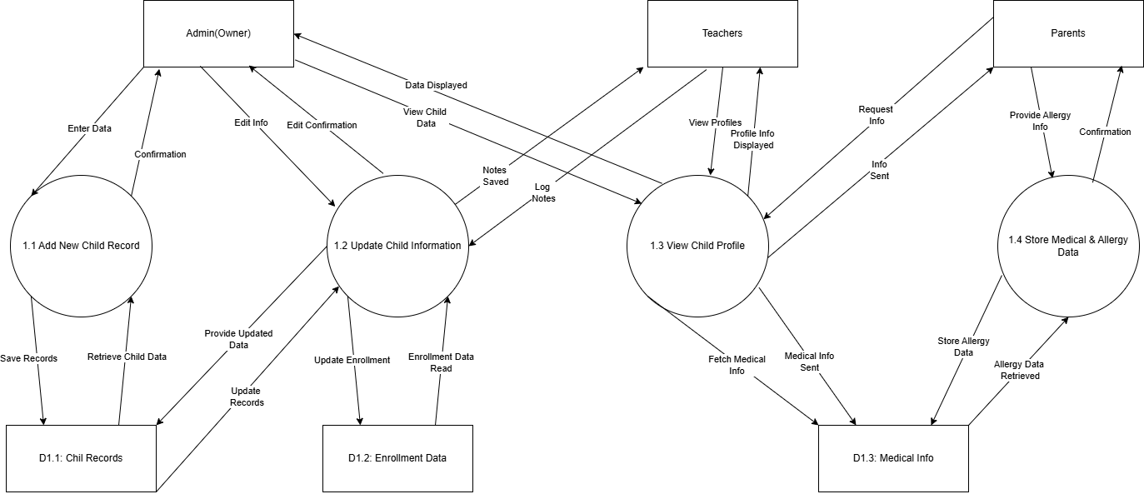

**DFD LVL.3**

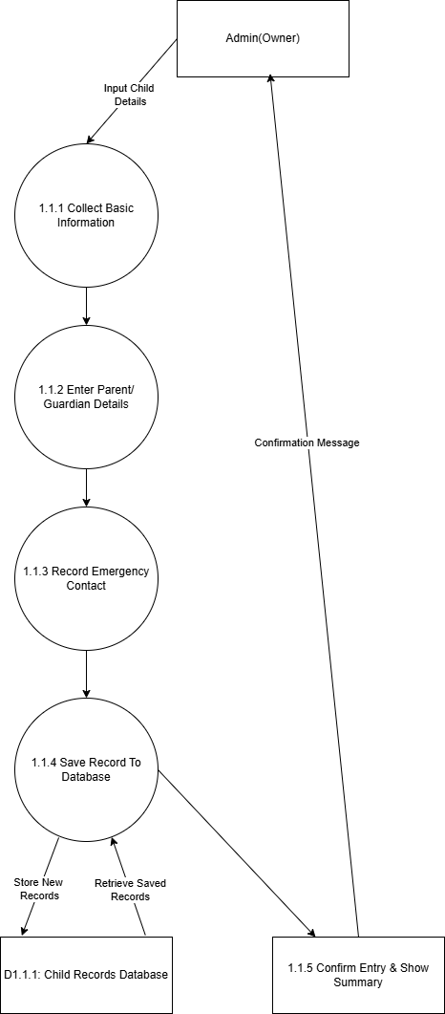

# User Scenarios

**👩‍💼Admin Scenarios**

**1. Grace Plans Next Month’s Activities**

**Scenario Title:** “Admin Sets the Calendar”

Grace, the administrator, logs into Nestify-MS and opens the “Events & Activities” panel.

After discussing with teachers and staff during a weekly internal meeting, she finalizes a

plan for upcoming activities , including a spring picnic, puppet show, and literacy day.

Once approved, she adds each event to the system calendar, writes a short description,

and schedules automatic notifications to be sent to parents. She also adds RSVP buttons

so parents can confirm attendance for their children.

**2. Grace Reviews Staff Requests**

**Scenario Title:** “Admin Responds to Inventory and Maintenance Alerts”

After logging in, Grace checks the system notifications and sees that a sanitar has

reported a broken sink in Classroom B and requested a restock of cleaning gloves. She

opens the “Maintenance Requests” tab, marks the issue as “In Progress,” and forwards

the request to the school’s maintenance team.

For the inventory alert, she updates the order form and marks the request as “Scheduled

for Purchase.”

**🧑‍🏫Teacher Scenarios**

**3. Tom Sends Weekly Progress Reports**

**Scenario Title:** “Teacher Connects with Parents”

Every Friday, Tom logs into Nestify-MS and selects his student list. For each child, he fills

out a weekly progress note , describing behavior, learning engagement, peer interactions,

and emotional wellbeing.

He mentions that Ava is adjusting well and making new friends, while Liam seemed quiet

this week and may benefit from more one-on-one time.

Once reports are completed, he clicks “Send Weekly Update.” Parents receive

personalized messages in their app inbox.

**4. Tom Takes Daily Attendance**

**Scenario Title:** “Teacher Records Attendance”

Each morning, Tom logs in and opens the Attendance section for his class. He sees that

Sofia hasn’t arrived and no absence was reported.

Using the built-in message tool, he quickly writes a note to her parent asking if everything

is okay and if Sofia will be attending today.

Other students are marked “Present,” and the record is saved automatically.

**5. Tom Requests Parent Meetings**

**Scenario Title:** “Teacher Schedules a Parent Conference”

Noticing some changes in Michael’s behavior and participation, Tom decides it’s time for a

conversation with his guardians.

He writes a short explanation and sends a request to the Admin via the system to schedule

a parent-teacher meeting.

The Admin reviews the request, schedules the date, and the parents are notified with a

meeting invite.

**👨‍🍳Chef Scenarios**

**6. Sara Creates a Weekly Meal Plan**

**Scenario Title:** “Chef Updates Menu for the Week”

Sara checks each child’s allergy and medical info through Nestify-MS. She notices that a

new child, Emma, has a nut allergy.

She modifies the weekly menu to remove nut-based items and adds alternatives.

Once finalized, she uploads the new meal plan for parents to view and leaves a note

asking for any feedback.

**7. Sara Reviews Feedback and Makes Adjustments**

**Scenario Title:** “Chef Responds to Parent Feedback”

Sara logs into the system and checks comments left by parents. One parent noted that

their child doesn’t like boiled carrots and asks for other veggie options.

Sara updates the plan for that class group and adds a variety of seasonal veggies. She then

posts an updated version and thanks the parent in the feedback section.

**🧹Sanitar Scenarios**

**8. Alex Reports a Broken Toy Cabinet**

**Scenario Title:** “Sanitar Submits a Maintenance Request”

During his morning rounds, Alex notices that the toy cabinet door in Room 3 is broken. He

logs in to Nestify-MS, clicks on “Report an Issue,” and fills out the form:

Category: Furniture

Issue: Toy Cabinet door hinge loose, unsafe for kids.

He submits the report, which alerts the Admin to take action.

**9. Alex Reviews Daily Tasks**

**Scenario Title:** “Sanitar Checks Task Assignments”

Every morning, Alex opens the system and sees his daily cleaning checklist:

• Sanitize play mats

• Refill tissue boxes

• Clean kitchen counter

He ticks off each completed item in the system. If he runs out of supplies, he

selects “Request Restock” and adds the needed products.

**👨‍👩‍👧 Parent Scenarios**

**10. Ana Reads the Weekly Progress Report**

**Scenario Title:** “Parent Receives Child Update”

Ana opens the Nestify-MS app and sees a message from her daughter’s teacher:

“Sofia had a great week! She's now playing more confidently with others and helped a

friend who was feeling shy.”

Ana replies, thanking the teacher and saying she’ll talk to Sofia about her positive

behavior.

**11. Parent Confirms Attendance for an Event**

**Scenario Title:** “Parent RSVPs for Puppet Show”

Ana receives a notification: “Puppet Show next Friday – confirm your child’s attendance.”

She clicks “Yes,” and the event is added to her calendar. A reminder is automatically

scheduled for one day before the event.

**12. Parent Views and Comments on Meal Plan**

**Scenario Title:** “Parent Reviews Weekly Meals”

Ana checks the newly posted meal plan and notices fish is being served twice. Since her

child dislikes fish, she comments:

“Could we consider a substitute for Thursday’s fish meal?”

The chef sees her feedback and updates the meal plan accordingly.

**13. Parent Chats with the Teacher**

**Scenario Title:** “Parent Requests Behavior Follow-Up”

Ana messages the teacher privately through the app:

“Hi, I’ve noticed Sofia has been quiet at home. Have you noticed anything similar?”

The teacher replies that she has been a little withdrawn and suggests a short meeting to

talk further.

# Use Case Diagrams

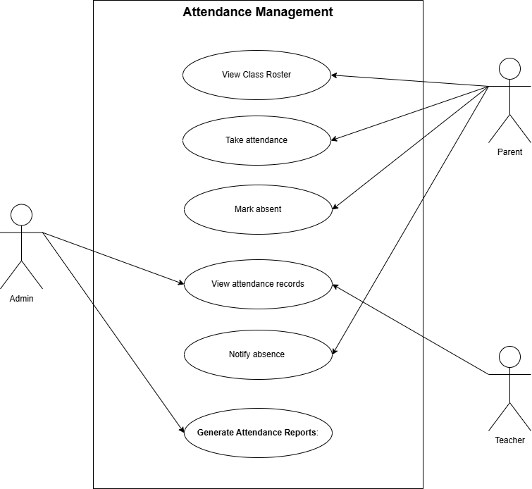

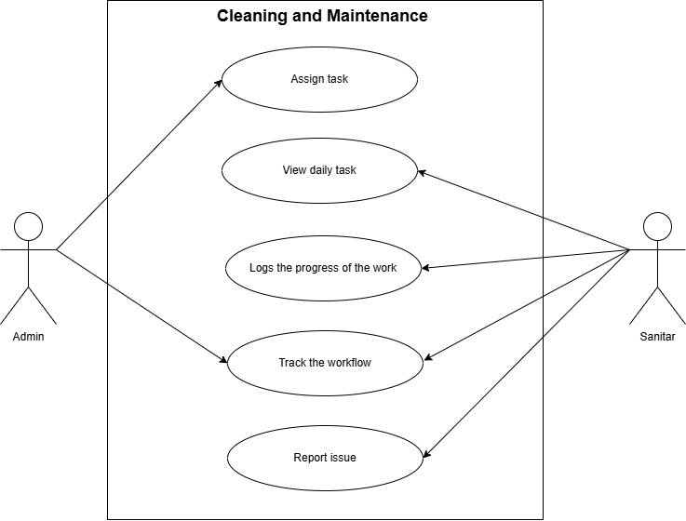

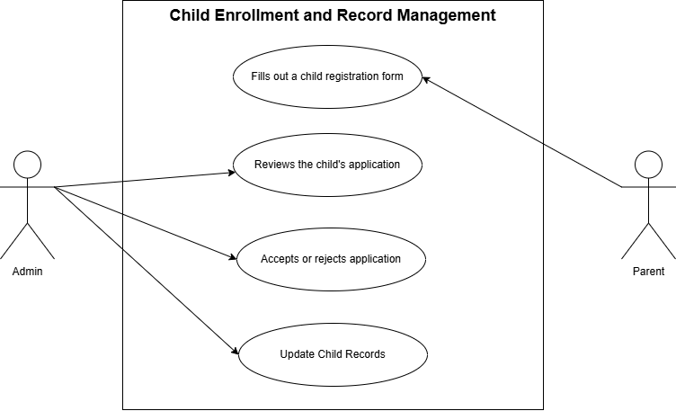

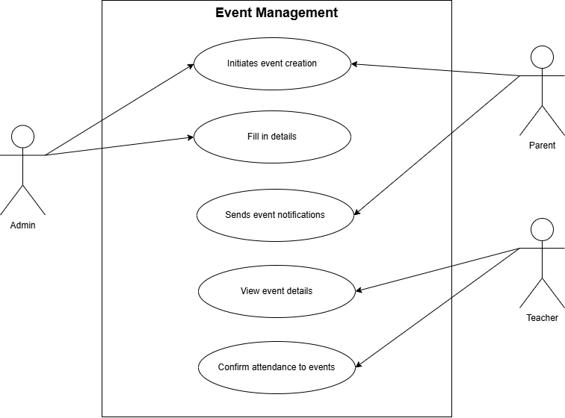

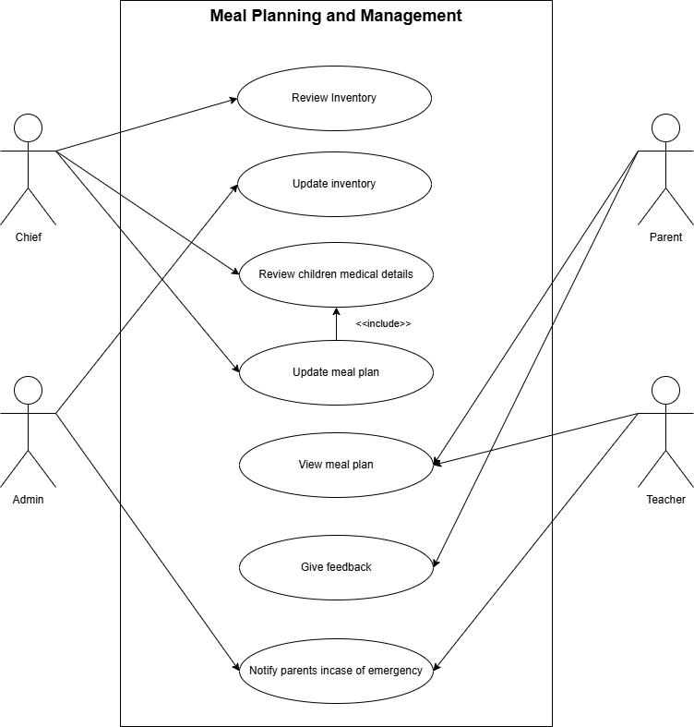

# Use Case Table

**Attendance Management**

|  |  |
| --- | --- |
| Use case name | View Class Roster |
| Summary | Displays a list of all students in the class. |
| Dependency | None |
| Actors | Staff |
| Precondition | Staff must be logged in. |
| Description of Main Sequence | Staff clicks on "View Roster"  System retrieves and displays class list |
| Description of Alternative Sequence | If class data is missing, an error message is  shown. |
| Special Requirements | None |
| Postcondition | Class list is successfully displayed. |

|  |  |
| --- | --- |
| Use case name | Take Attendance |
| Summary | Allows marking students as present or  absent. |
| Dependency | View Class Roster |
| Actors | Staff |
| Precondition | Class roster must be available. |
| Description of Main Sequence | * Staff opens attendance page * Marks each student * Clicks "Save" |
| Description of Alternative Sequence | If save is not clicked, data is lost. |
| Special Requirements | View Class Roster |
| Postcondition | Attendance is recorded. |

|  |  |
| --- | --- |
| Use case name | Mark Absent |
| Summary | Marks a student specifically as absent. |
| Dependency | Take Attendance |
| Actors | Staff |
| Precondition | A student is selected. |
| Description of Main Sequence | * Staff selects student * Clicks "Mark Absent" |
| Description of Alternative Sequence | If no student is selected, an error is shown. |
| Special Requirements | Take Attendance |
| Postcondition | Absence is recorded. |

|  |  |
| --- | --- |
| Use case name | View Attendance Records |
| Summary | Views past attendance logs. |
| Dependency | Take Attendance |
| Actors | Staff, Admin |
| Precondition | User must be logged in. |
| Description of Main Sequence | * User selects a date range * System shows attendance logs |
| Description of Alternative Sequence | If no records found, a "no records"  message appears. |
| Special Requirements | Take Attendance |
| Postcondition | Records are displayed. |

|  |  |
| --- | --- |
| Use case name | Notify Absence |
| Summary | Sends notification to parents about  absence. |
| Dependency | Mark Absent |
| Actors | System |
| Precondition | Student must be marked absent. |
| Description of Main Sequence | * Absence marked * System sends message to parent |
| Description of Alternative Sequence | If no contact info, fail to send |
| Special Requirements | Mark Absent |
| Postcondition | Notification is sent. |

|  |  |
| --- | --- |
| Use case name | Generate Attendance Reports |
| Summary | Generates downloadable reports based on attendance. |
| Dependency |  |
| Actors | Admin |
| Precondition | Attendance data must be available. |
| Description of Main Sequence | * Admin selects criteria * System compiles data and exports |
| Description of Alternative Sequence | No data = error shown |
| Special Requirements | View Attendance Records |
| Postcondition | Report generated and saved. |

**Cleaning and Maintenance**

|  |  |
| --- | --- |
| Use case name | Assign Task |
| Summary | Assigns cleaning/maintenance tasks to  staff. |
| Dependency | None |
| Actors | Admin |
| Precondition | Admin logged in. |
| Description of Main Sequence | * Select staff * Add task details * Confirm assignment |
| Description of Alternative Sequence | Invalid staff → error |
| Special Requirements | None |
| Postcondition | Task is assigned. |

|  |  |
| --- | --- |
| Use case name | View Daily Task |
| Summary | Views list of daily assigned tasks. |
| Dependency | Assign Task |
| Actors | Staff |
| Precondition | Task must be assigned. |
| Description of Main Sequence | Staff opens task tab |
| Description of Alternative Sequence | No tasks assigned → message |
| Special Requirements | Assign Task |
| Postcondition | Task list is displayed. |

|  |  |
| --- | --- |
| Use case name | Logs the Progress of the Work |
| Summary | Updates system with progress. |
| Dependency | View Daily Task |
| Actors | Staff |
| Precondition | Task is ongoing. |
| Description of Main Sequence | * Staff selects task * Updates progress * Saves |
| Description of Alternative Sequence | Invalid input → show error |
| Special Requirements | View Daily Task |
| Postcondition | Progress status is saved. |

|  |  |
| --- | --- |
| Use case name | Track the Workflow |
| Summary | Tracks all task statuses. |
| Dependency | Logs Progress |
| Actors | Asmin |
| Precondition | Staff tasks in progress. |
| Description of Main Sequence | Admin opens tracking dashboard |
| Description of Alternative Sequence | No data → chart empty |
| Special Requirements | Logs Progress |
| Postcondition | Admin sees workflow chart. |

|  |  |
| --- | --- |
| Use case name | Report Issue |
| Summary | Reports problems in assigned task. |
| Dependency | Logs the Progress |
| Actors | Staff |
| Precondition | Task must be selected. |
| Description of Main Sequence | * Click "Report Issue" * Describe problem * Submit |
| Description of Alternative Sequence | Blank form → show error |
| Special Requirements | Logs the Progress |
| Postcondition | Admin is notified. |

**Event Management**

|  |  |
| --- | --- |
| Use case name | Initiates Event Creation |
| Summary | Starts setting up a new event. |
| Dependency | None |
| Actors | Admin |
| Precondition | Admin is logged in. |
| Description of Main Sequence | Click “Create Event” |
| Description of Alternative Sequence | No permission → blocked |
| Special Requirements | None |
| Postcondition | Event form opened. |

|  |  |
| --- | --- |
| Use case name | Fill in Details |
| Summary | Inputs event information. |
| Dependency | Initiates Event Creation |
| Actors | Admin |
| Precondition | Creation initiated. |
| Description of Main Sequence | * Fill form * Save |
| Description of Alternative Sequence | Incomplete fields → error |
| Special Requirements | Initiates Event Creation |
| Postcondition | Event is saved. |

|  |  |
| --- | --- |
| Use case name | Sends Event Notifications |
| Summary | Notifies all users about an event. |
| Dependency |  |
| Actors | System |
| Precondition | Event is created. |
| Description of Main Sequence | * Event saved * System sends message |
| Description of Alternative Sequence | No users → fail silently |
| Special Requirements | Fill in Details |
| Postcondition | Users are notified. |

|  |  |
| --- | --- |
| Use case name | View Event Details |
| Summary | Allows viewing event info. |
| Dependency | None |
| Actors | Staff, Parents |
| Precondition | Event exists. |
| Description of Main Sequence | Click on event |
| Description of Alternative Sequence | Event not found → error |
| Special Requirements | None |
| Postcondition | Info displayed. |

|  |  |
| --- | --- |
| Use case name | Confirm Attendance to Events |
| Summary | Confirms participation in an event. |
| Dependency | View Event Details |
| Actors | Parents |
| Precondition | Event info must be viewed. |
| Description of Main Sequence | Click “Confirm” or not |
| Description of Alternative Sequence | Click “Confirm” |
| Special Requirements | View Event Details |
| Post Condition | Confirmation saved. |

**Meal Planning and Management**

|  |  |
| --- | --- |
| Use case name | Review Inventory |
| Summary | Views current stock of food items. |
| Dependency | None |
| Actors | Staff |
| Precondition | Staff logged in. |
| Description of Main Sequence | Open inventory tab |
| Description of Alternative Sequence | No items → show “empty” |
| Special Requirements | None |
| Postcondition | Inventory shown. |
| Use case name | Update Inventory |
| Summary | Edits or adds stock info. |
| Dependency | Review Inventory |
| Actors | Staff |
| Precondition | Inventory visible. |
| Description of Main Sequence | * Select item * Edit * Save |
| Description of Alternative Sequence | Invalid input → show error |
| Special Requirements | Review Inventory |
| Postcondition | Inventory updated. |

|  |  |
| --- | --- |
| Use case name | Review Children Medical Details |
| Summary | Checks dietary or allergy needs. |
| Dependency | None |
| Actors | Staff |
| Precondition | Children registered. |
| Description of Main Sequence | * Select child * View details |
| Description of Alternative Sequence | No child found → fail |
| Special Requirements | None |
| Postcondition | Info displayed. |

|  |  |
| --- | --- |
| Use case name | Update Meal Plan |
| Summary | Adjusts food plan for children. |
| Dependency | Review Inventory, Review Medical Details |
| Actors | Admin |
| Precondition | Inventory + medical data available. |
| Description of Main Sequence | * Select day * Choose meals |
| Description of Alternative Sequence | Allergic food selected → warning |
| Special Requirements | Review Inventory, Review Medical Details |
| Postcondition | Meal plan saved. |

|  |  |
| --- | --- |
| Use case name | View Meal Plan |
| Summary | Displays the meal plan. |
| Dependency | Update Meal Plan |
| Actors | Staff, Parents |
| Precondition | Meal plan created. |
| Description of Main Sequence | Open meal plan tab |
| Description of Alternative Sequence | No meal plan → “unavailable” message |
| Special Requirements | Update Meal Plan |
| Postcondition | Info shown. |

|  |  |
| --- | --- |
| Use case name | Give Feedback |
| Summary | Provides meal-related input. |
| Dependency | Meals served. |
| Actors | Parents |
| Precondition | View Meal Plan |
| Description of Main Sequence | * Click feedback * Submit |
| Description of Alternative Sequence | Empty form → prompt |
| Special Requirements | View Meal Plan |
| Postcondition | Feedback recorded. |

|  |  |
| --- | --- |
| Use case name | Notify Parents in Case of Emergency |
| Summary | Sends emergency alerts about food or  health. |
| Dependency | Review Children Medical Details |
| Actors | Teacher, System |
| Precondition | Emergency identified. |
| Description of Main Sequence | * Emergency triggered * System sends message |
| Description of Alternative Sequence | No contact |
| Special Requirements | Review Children Medical Details |
| Postcondition | Parents alerted. |

**Child Enrollment and Record Management**

|  |  |
| --- | --- |
| Use case name | Fills out child registration form |
| Summary | Fills in the form to begin enrolling a new  child. |
| Dependency | None |
| Actors | Parent |
| Precondition | Has access to the registration form. |
| Description of Main Sequence | Opens the form  Enters child's data Reviews  Submits the form. |
| Description of Alternative Sequence | Saves form as draft to complete later. |
| Special Requirements | Validation for required fields; form must  support saving drafts. |
| Postcondition | The child registration form is submitted  and stored for review. |

|  |  |
| --- | --- |
| Use case name | Reviews the child's application |
| Summary | Admin reviews a submitted child  registration form. |
| Dependency | Form must be submitted. |
| Actors | Admin |
| Precondition | Registration form has been submitted and  is accessible. |
| Description of Main Sequence | Selects pending application  Reviews form details  Prepares decision. |
| Description of Alternative Sequence | Admin requests additional information  from parents before proceeding. |
| Special Requirements | Interface to highlight missing/incomplete  fields. |
| Postcondition | Application is either accepted, rejected, or  marked for follow-up. |

|  |  |
| --- | --- |
| Use case name | Accepts or rejects application |
| Summary | Finalizes the enrollment decision for a  child. |
| Dependency | None |
| Actors | Admin |
| Precondition | Application has been reviewed. |
| Description of Main Sequence | Staff chooses “Accept” or “Reject”  System logs decision. Notifies parent. |
| Description of Alternative Sequence | Staff marks application as “On Hold” or  “Pending”. |
| Special Requirements | Confirmation prompt before submission of  final decision. |
| Postcondition | System updates child’s enrollment status  accordingly. |

|  |  |
| --- | --- |
| Use case name | Update Child Records |
| Summary | Enters the accepted child's information  into the system as a new official record. |
| Dependency | Accepts or rejects application |
| Actors | Admin, System |
| Precondition | The child’s application has been accepted. |
| Description of Main Sequence | Staff retrieves accepted application  Enters complete child info Submits. |
| Description of Alternative Sequence | Edits auto-filled fields before final save. |
| Special Requirements | System should verify that application is  accepted before allowing update. |
| Postcondition | Child is added to the system as a  registered member with complete details. |

# Activity Diagrams

**Attendance Activity Diagram**

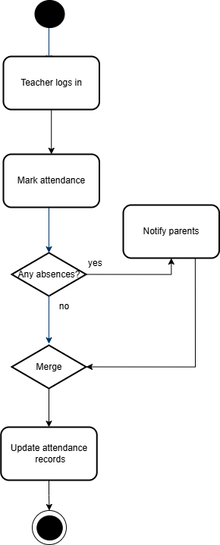

**Cleaning Activity Diagram**

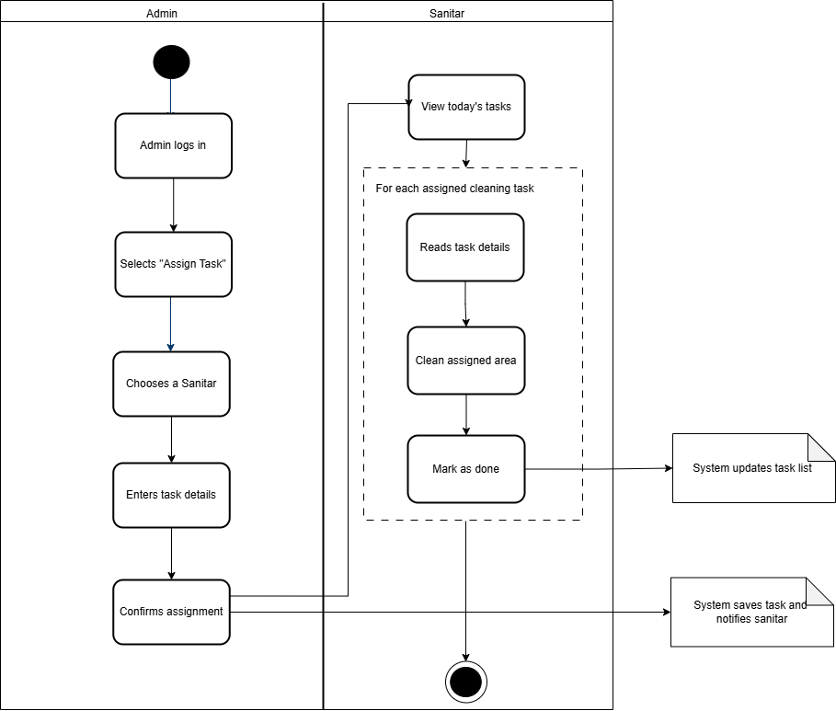

**Enrollment Activity Diagram**

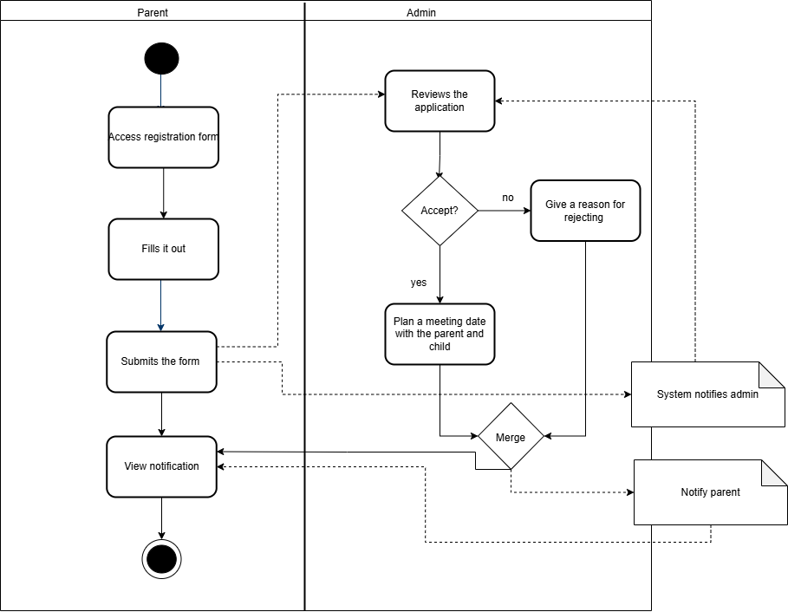

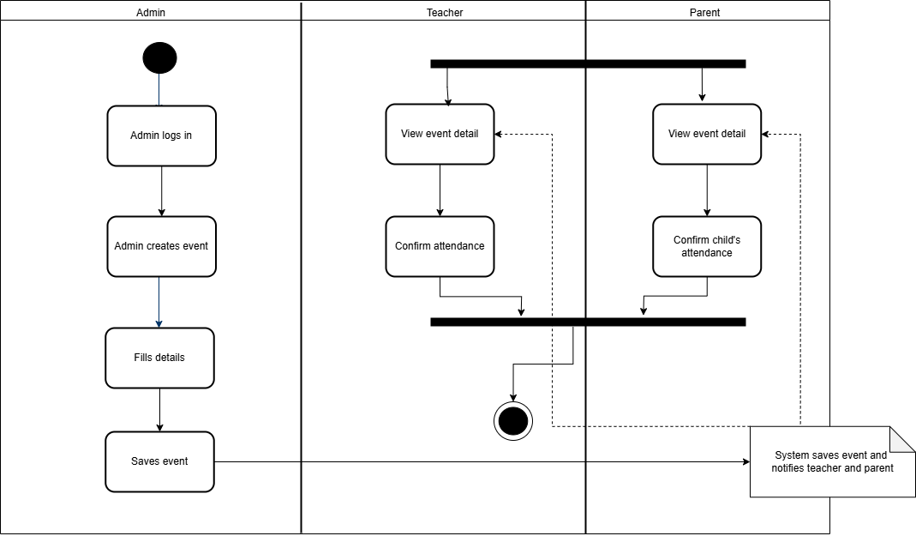**Event Activity Diagram**

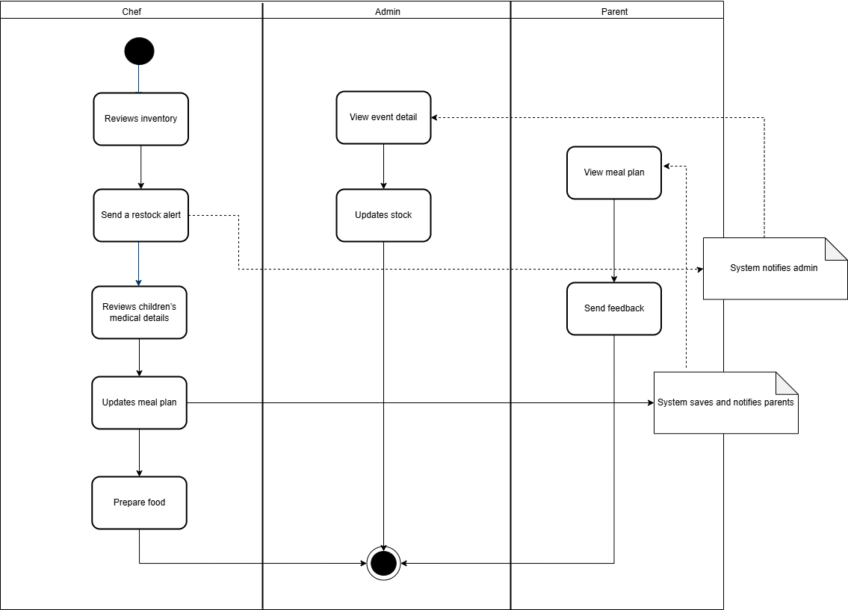**Meal Activity Diagram**

# State Diagrams

**Attendance State Diagram**

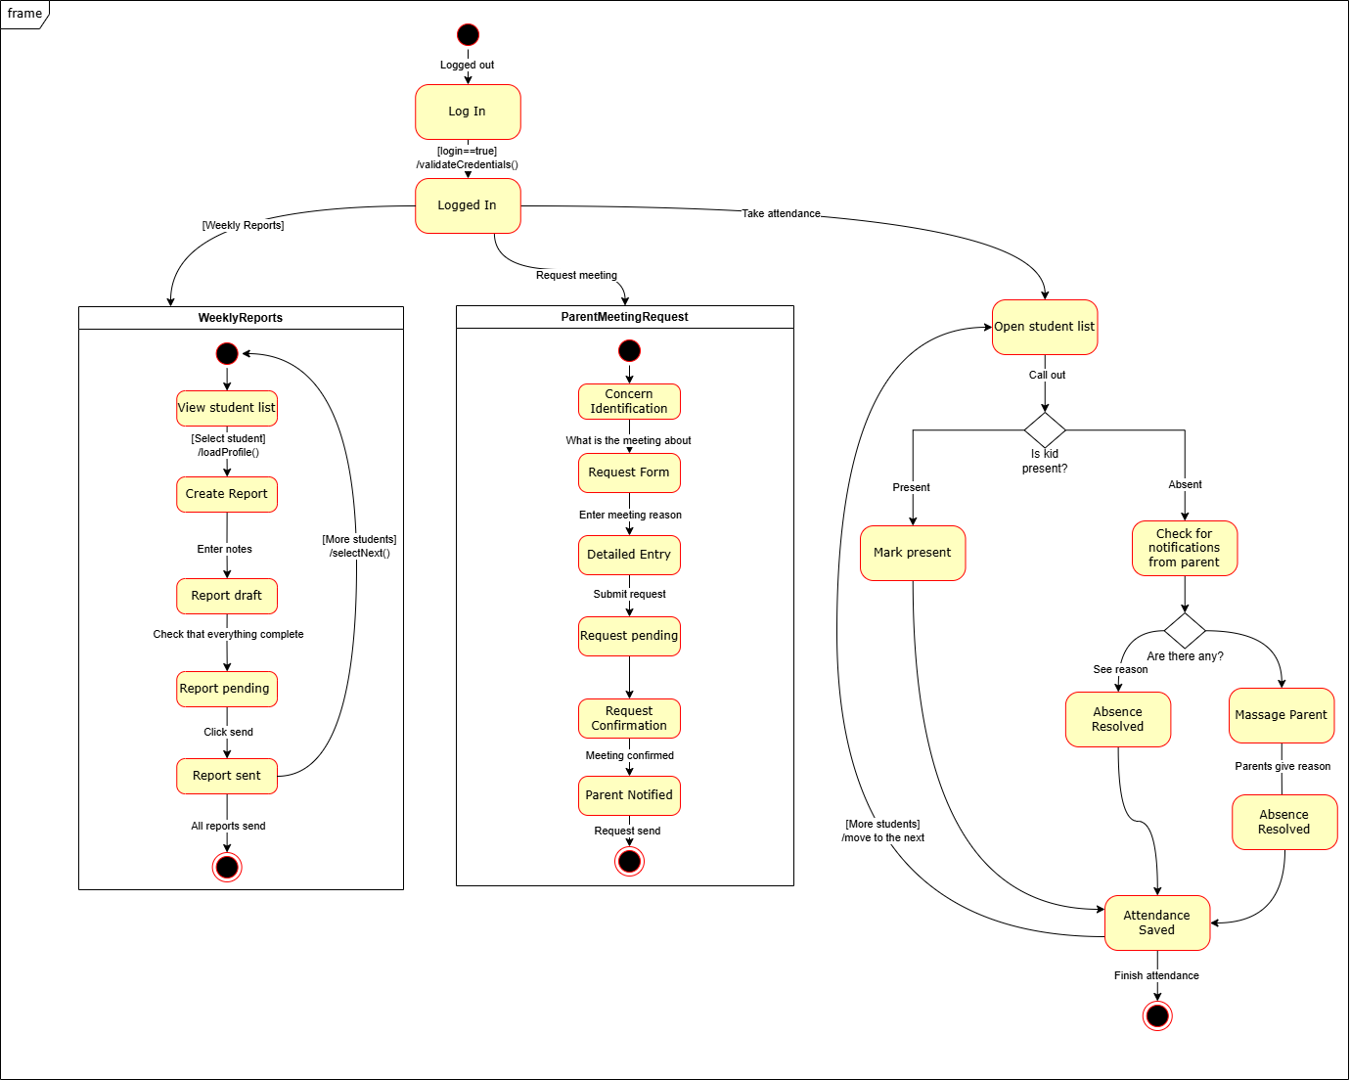

**Sanitar State Diagram**

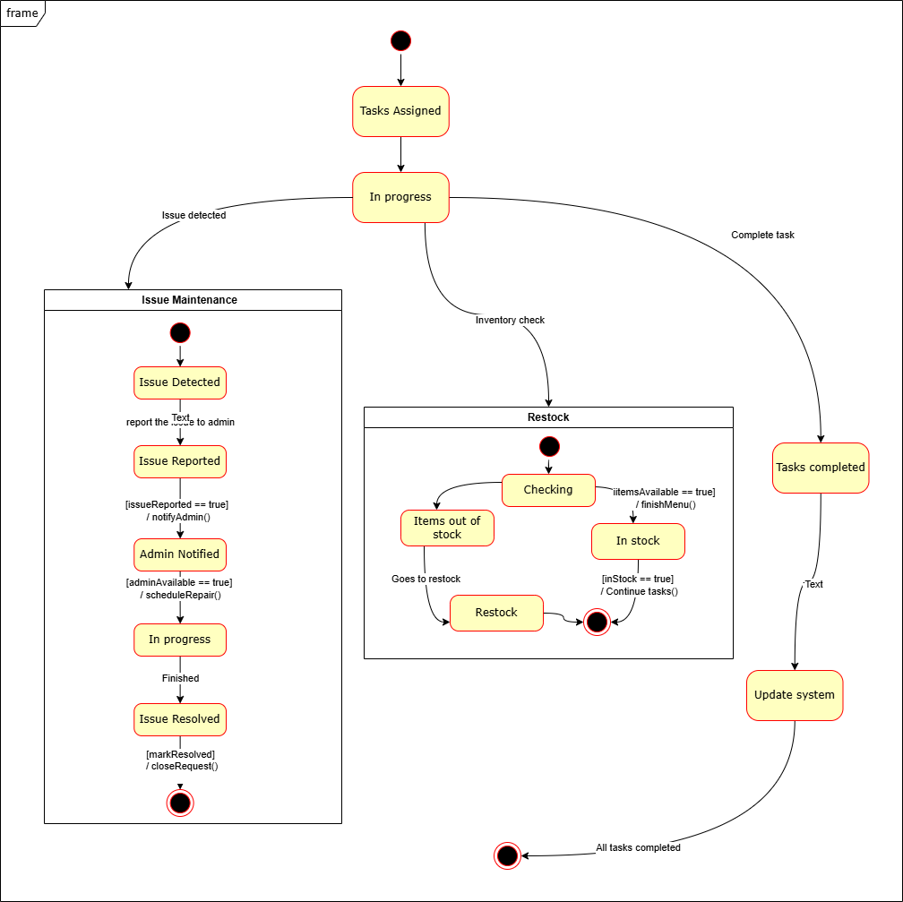

**Enrollment State Diagram**

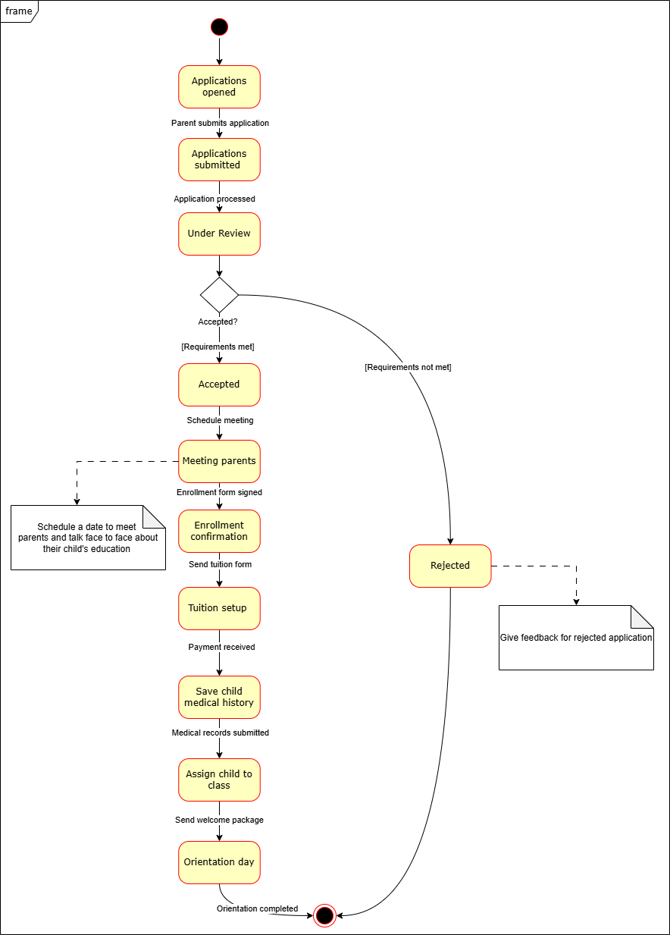

**Event State Diagram**

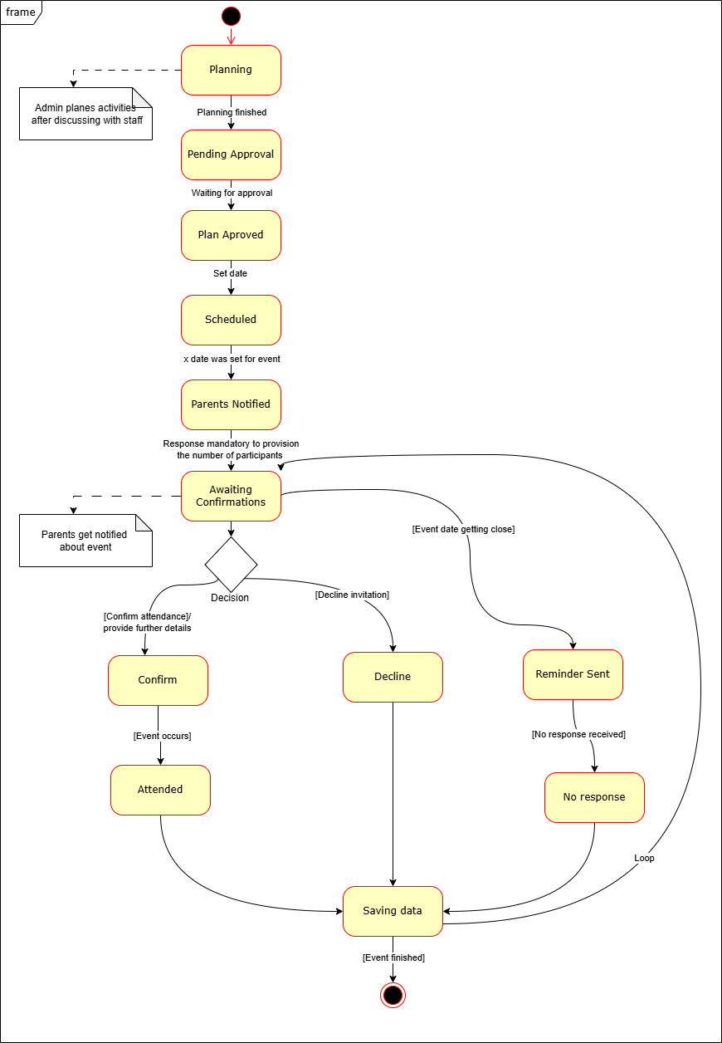

**Meal State Diagram**

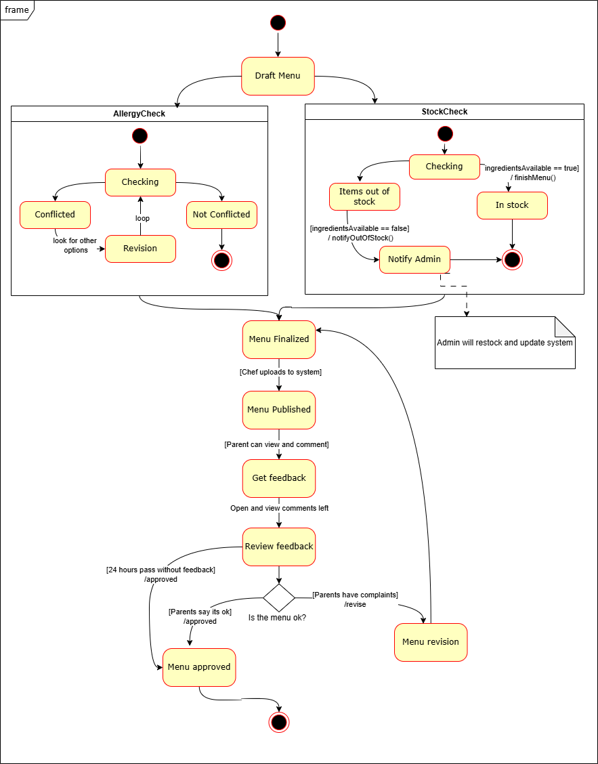

# Sequence Diagrams

**Attendance Sequence Diagram**

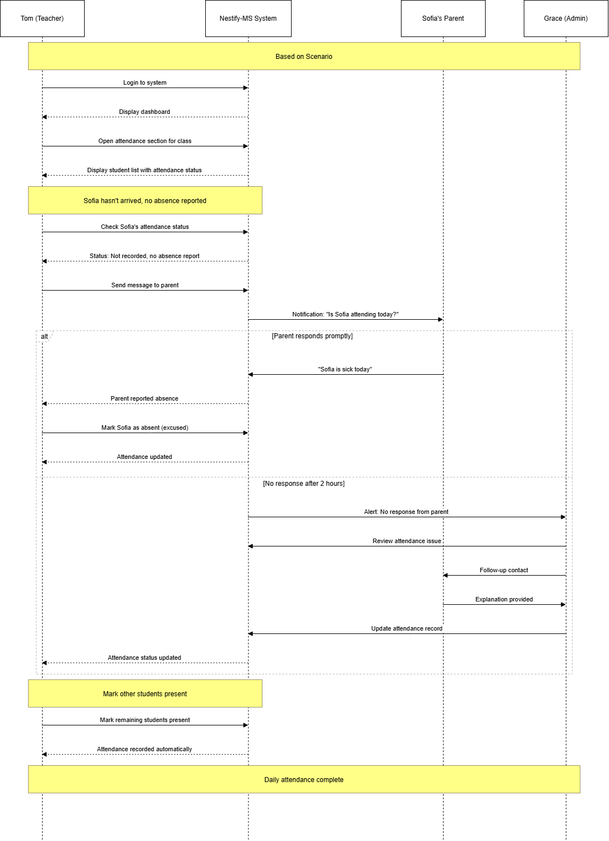

**Cleaning Sequence Diagram**

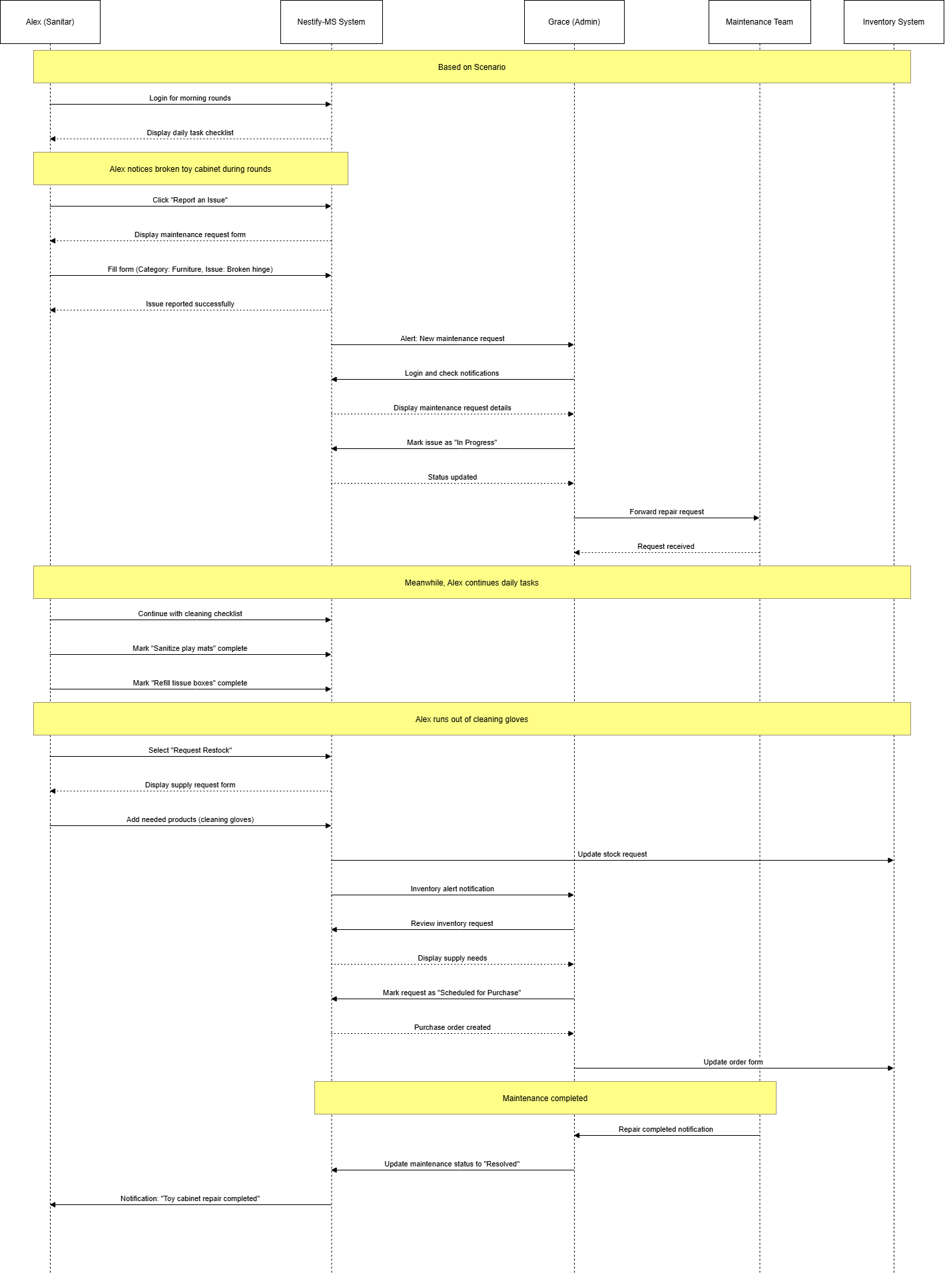

**Meal Plan Sequence Diagram**

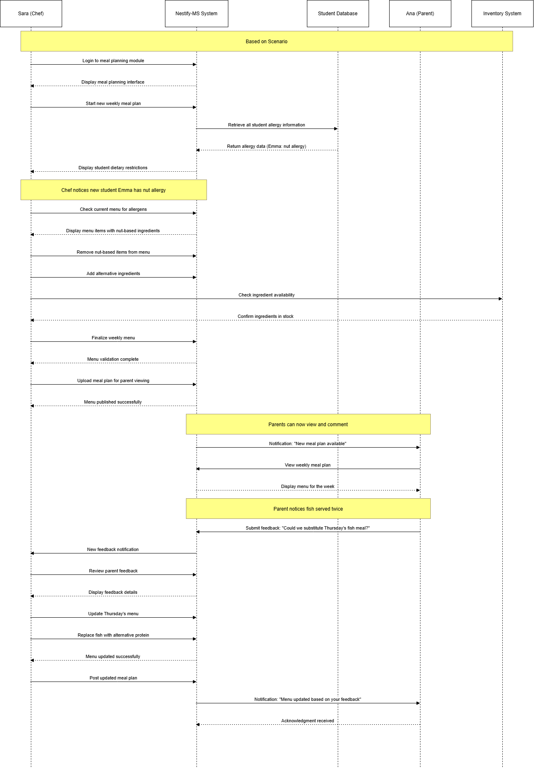

**Event Sequence Diagram**

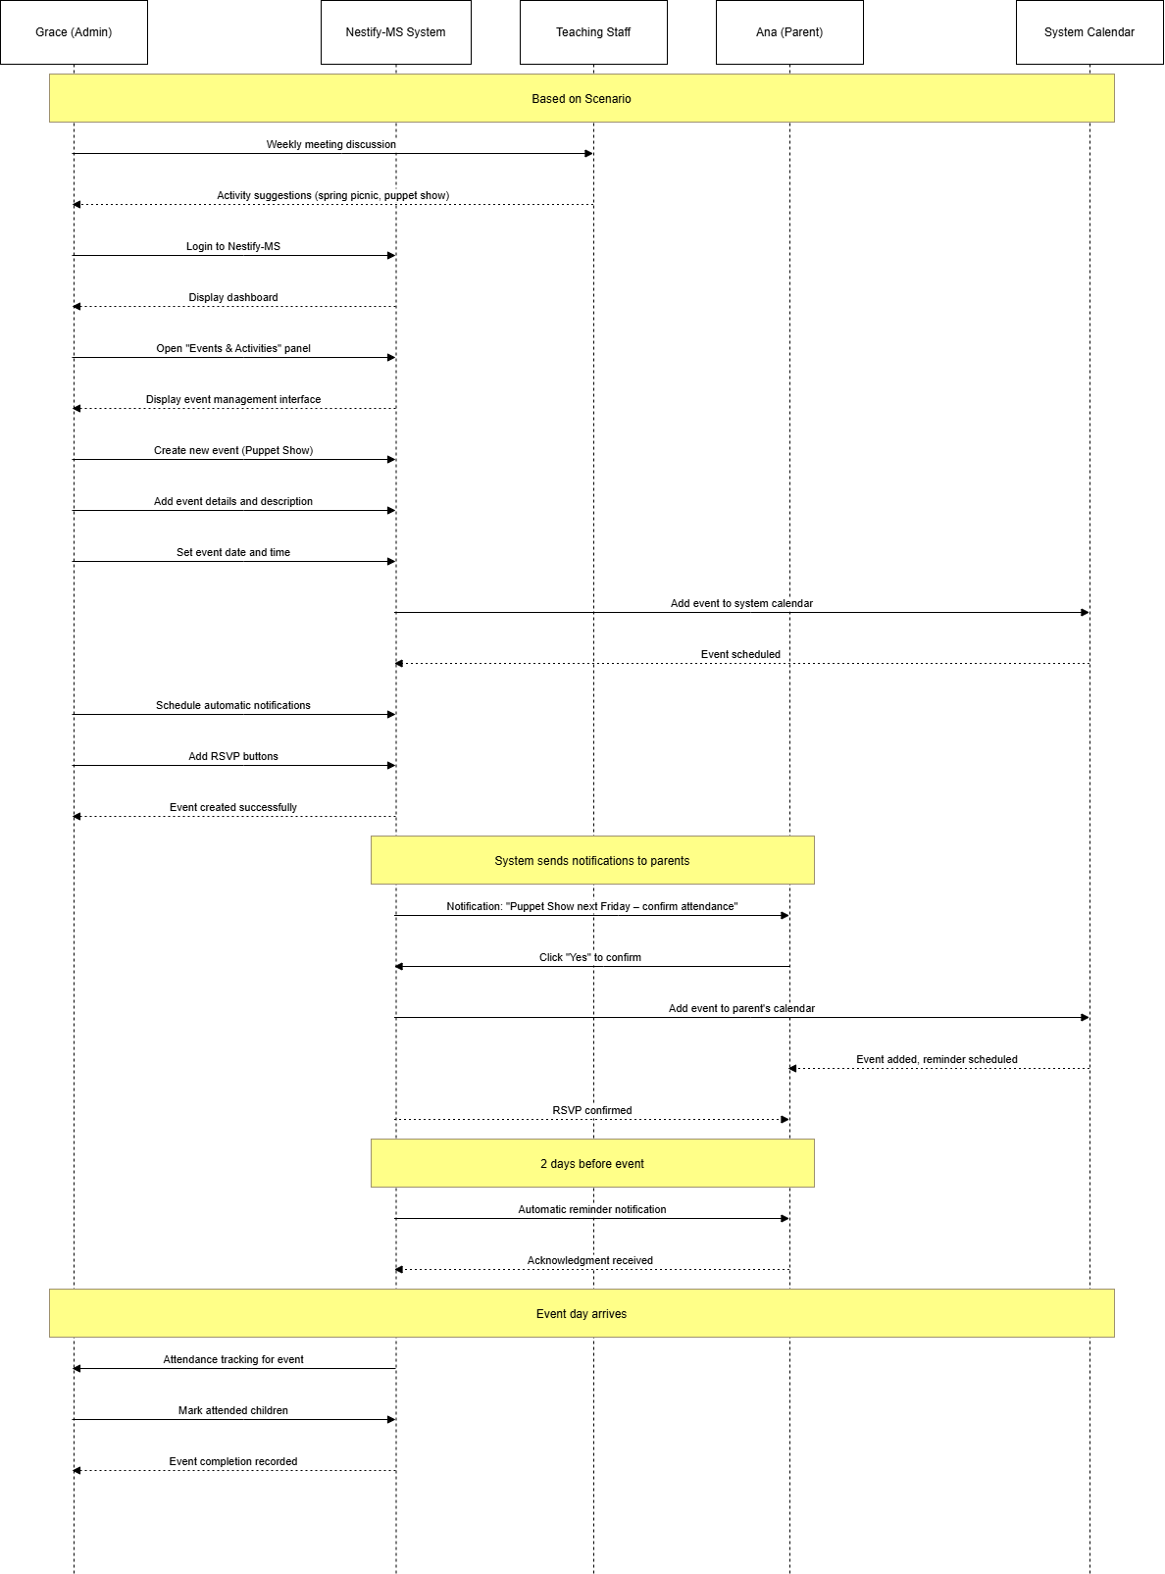

**Raport Sequence Diagram**

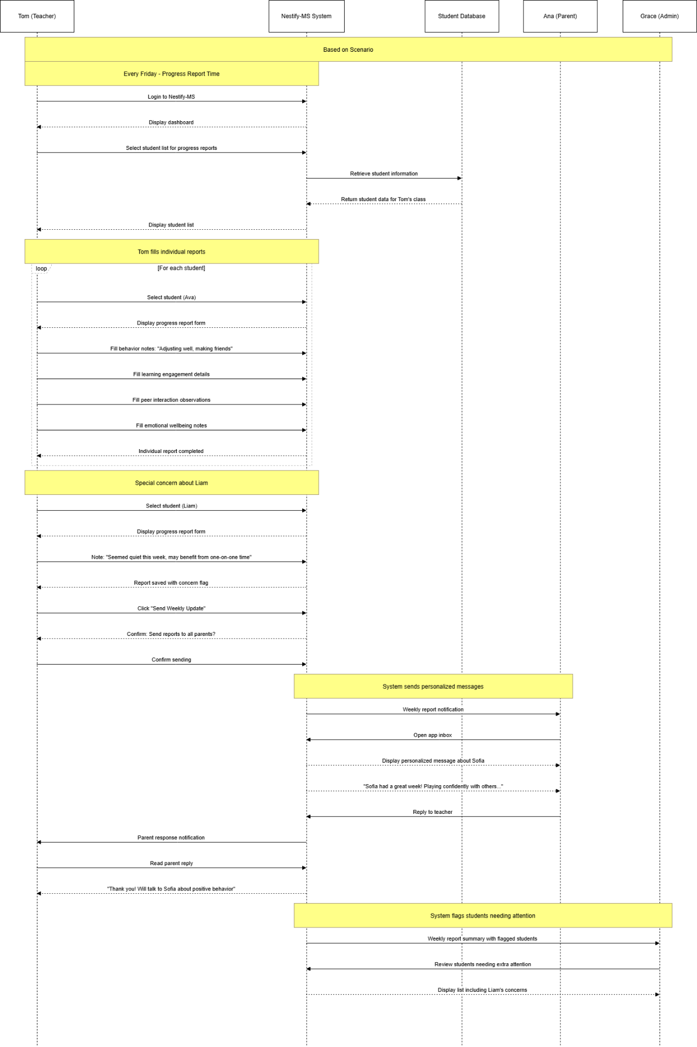

# Collaboratioon Diagrams

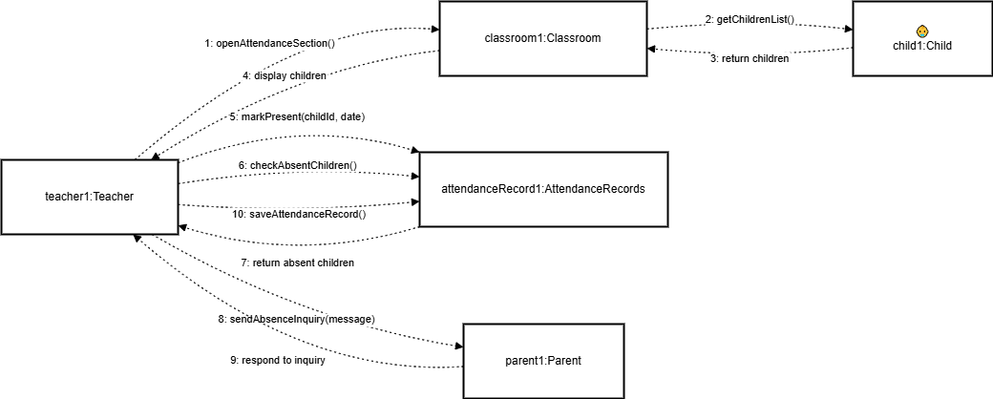**Attendance Collaboration Diagram**

**Cleaning Collaboration Diagram**

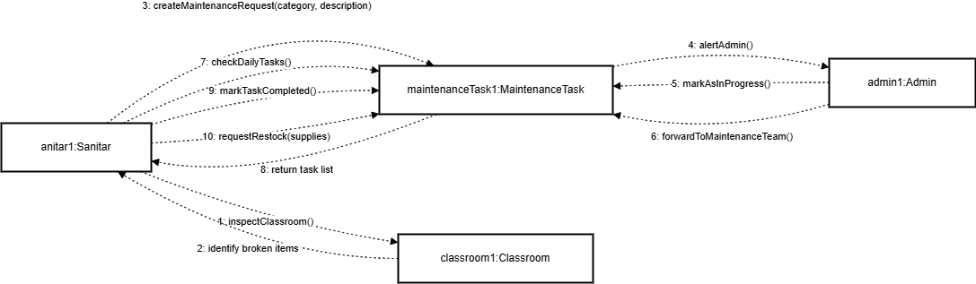

**Event Collaboration Diagram**

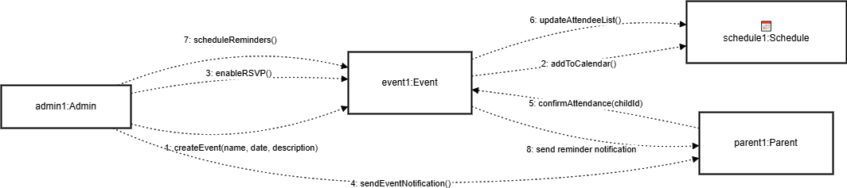

**Meal Plan Collaboration Diagram**

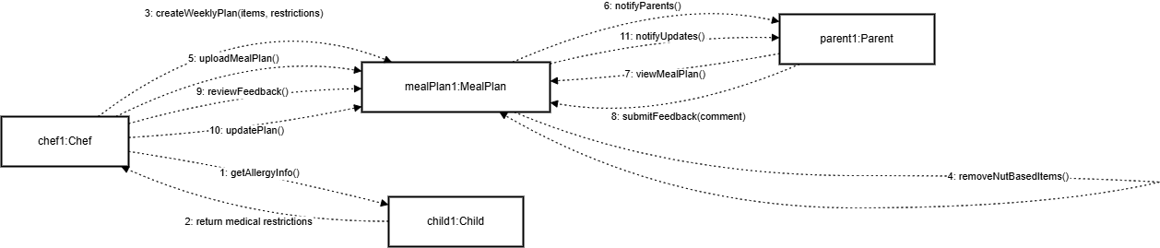

**Raport Collaboration Diagram**

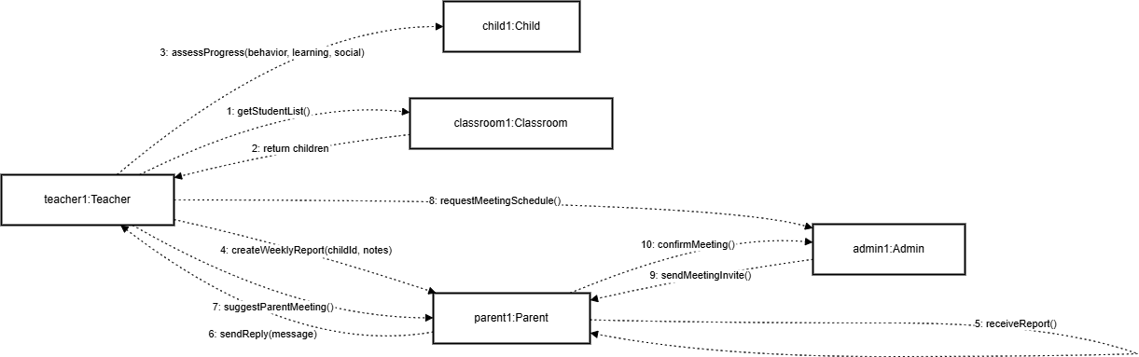

# Interaction Diagrams

**Attendance Interaction Diagram**

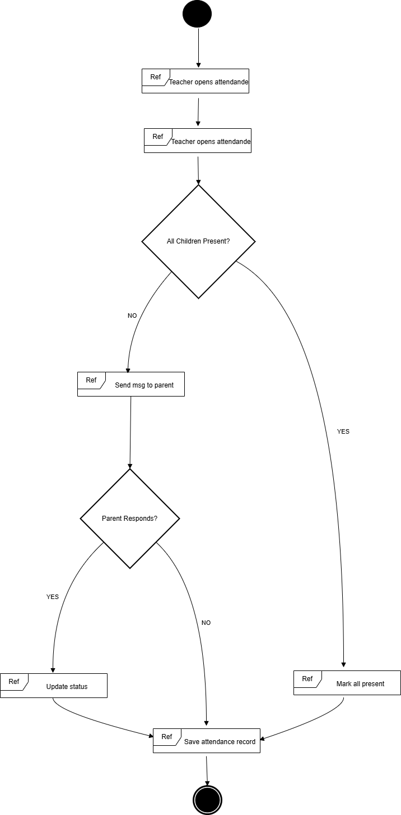

**Cleaning Interaction Diagram**

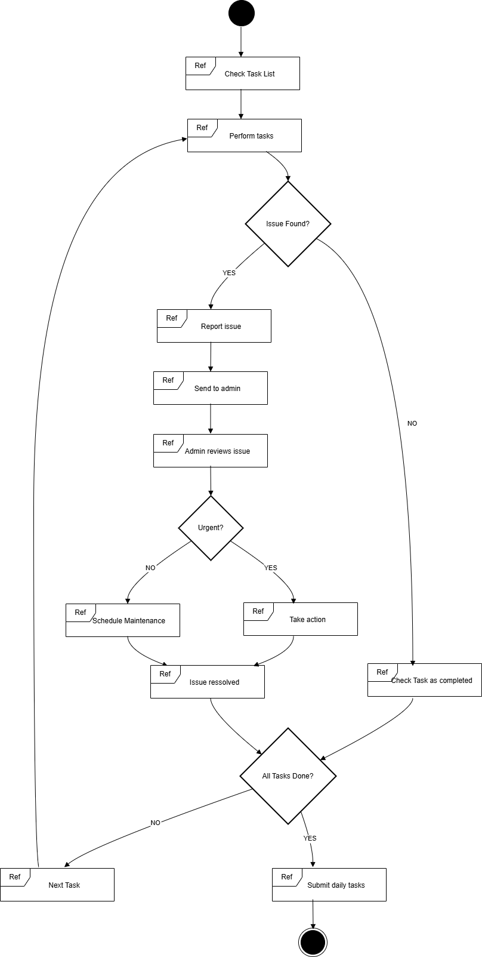

**Event Interaction Diagram**

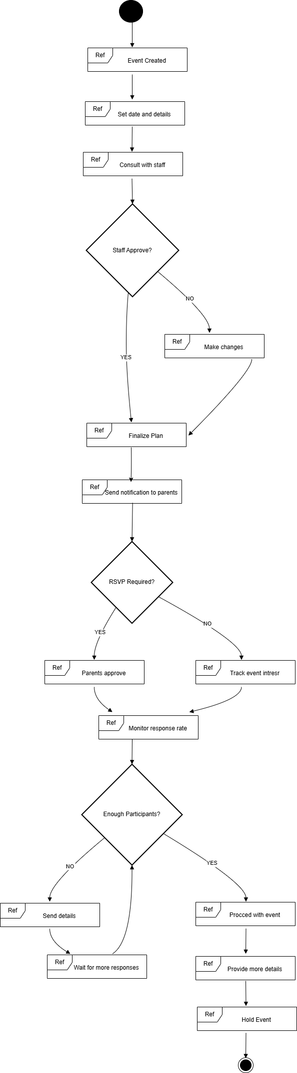

**Meal Plan Interaction Diagram**

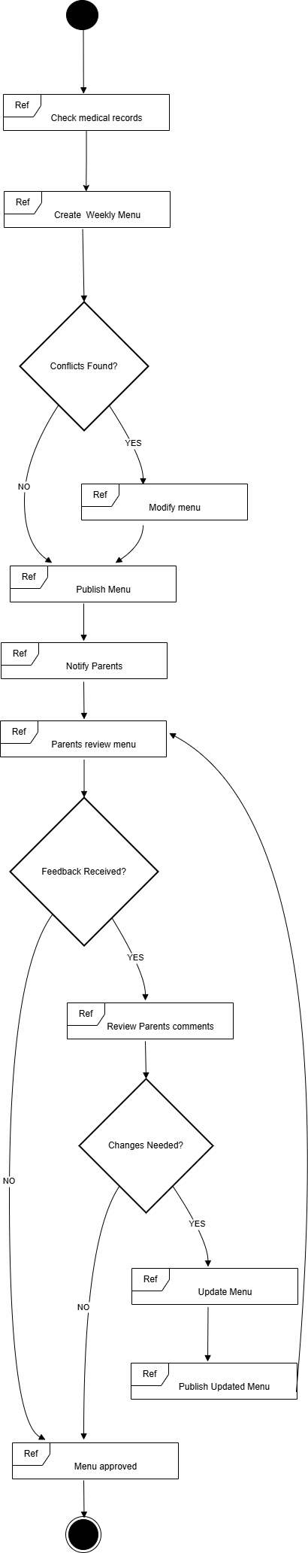

**Enrollment Interaction Diagram**

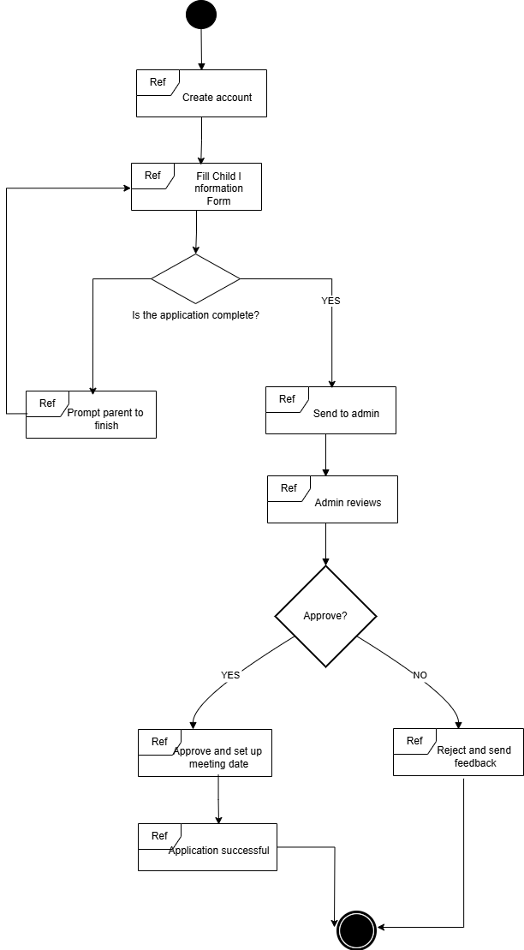

# Design Patterns

### **Creational Patterns:**

**Factory Method Pattern**

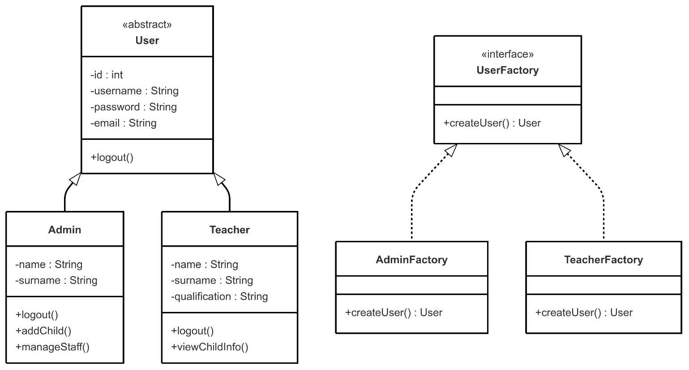

**Builder Pattern**

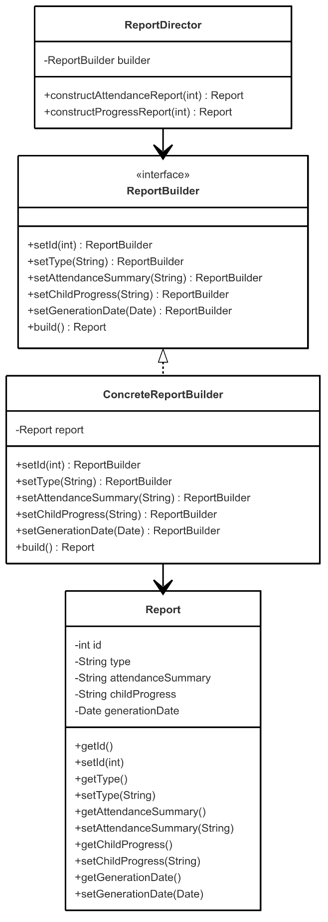

### **Structural Patterns:**

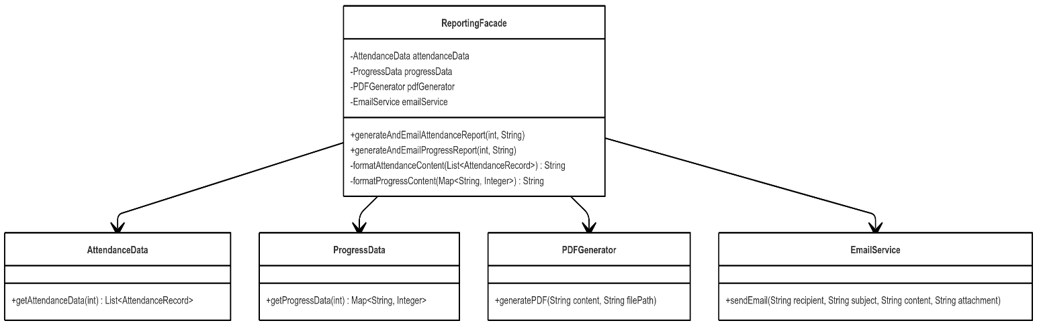**Facade Pattern**

**Adapter Pattern**

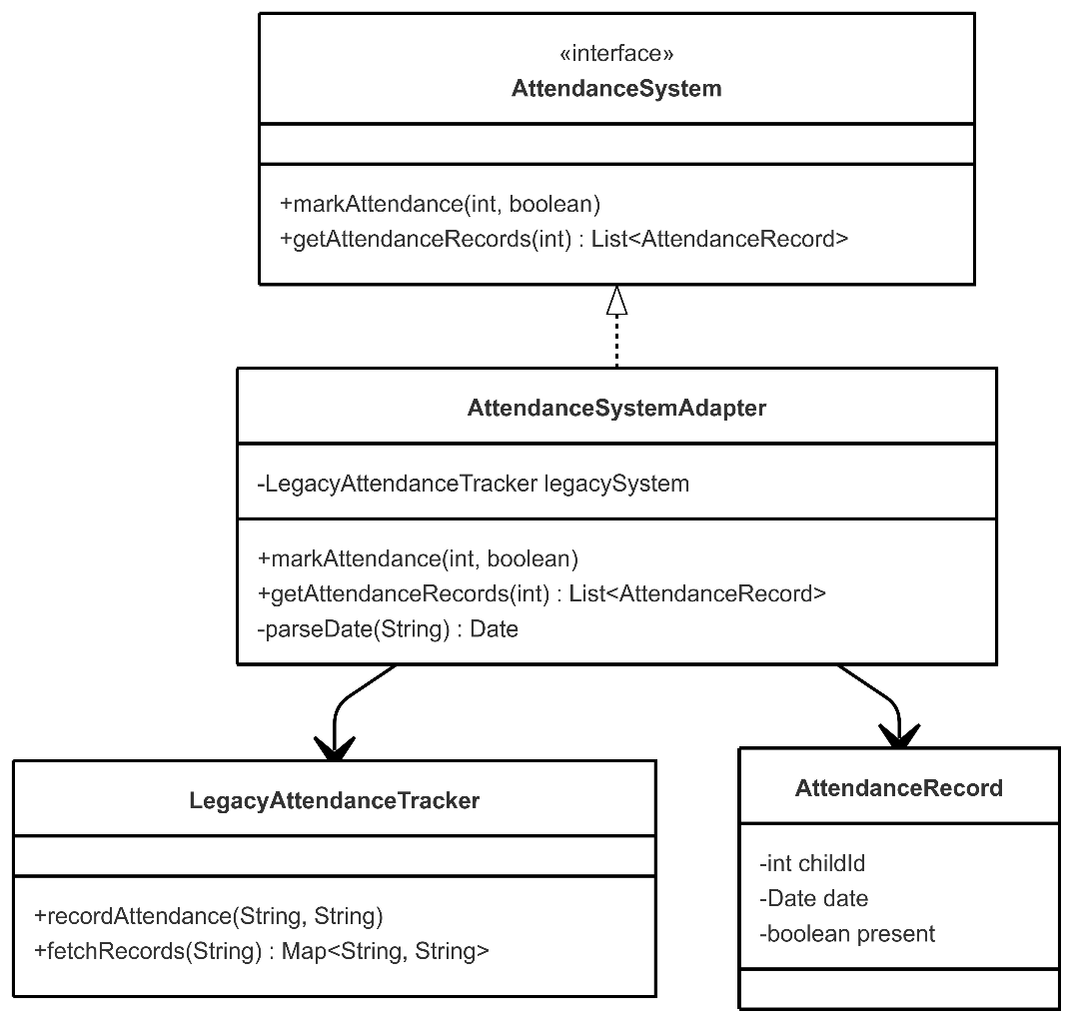

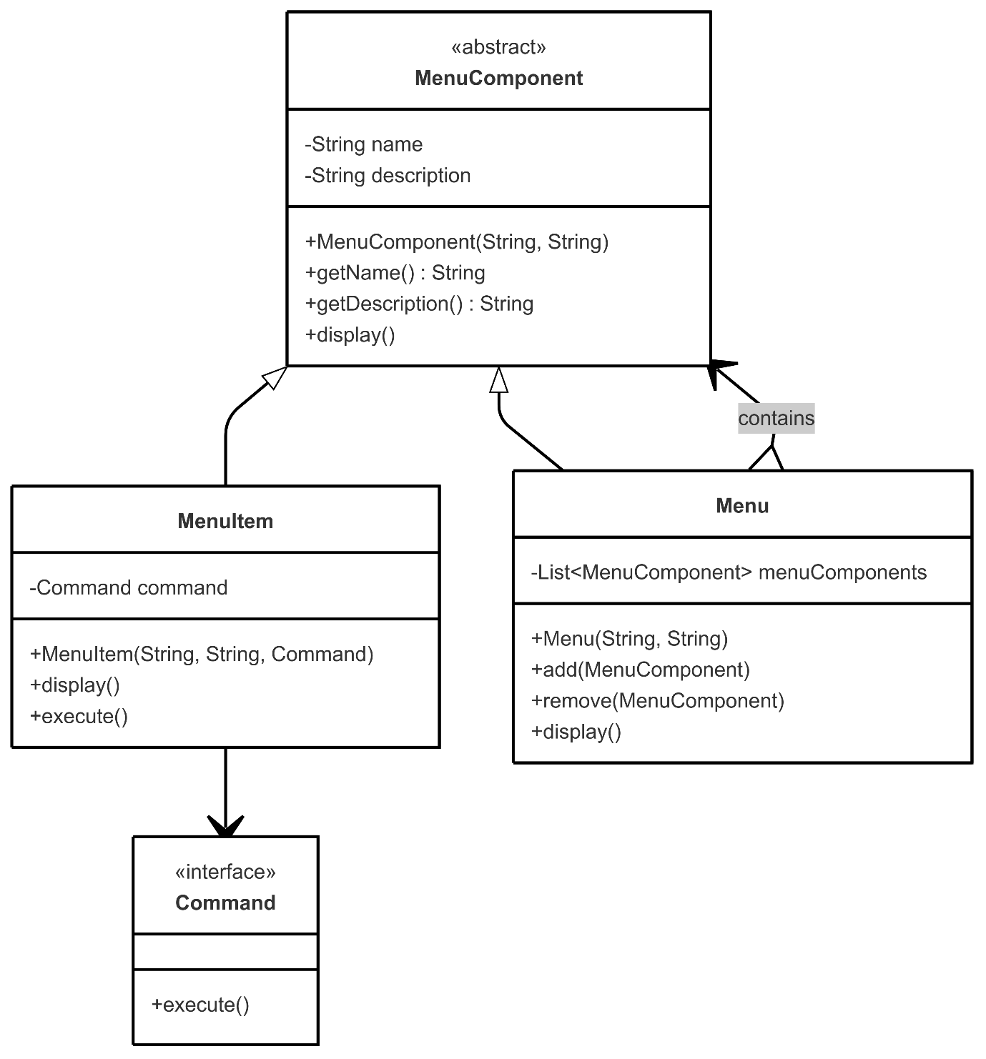

**Composite Pattern**

### **Behavioral Patterns:**

**Command Pattern**

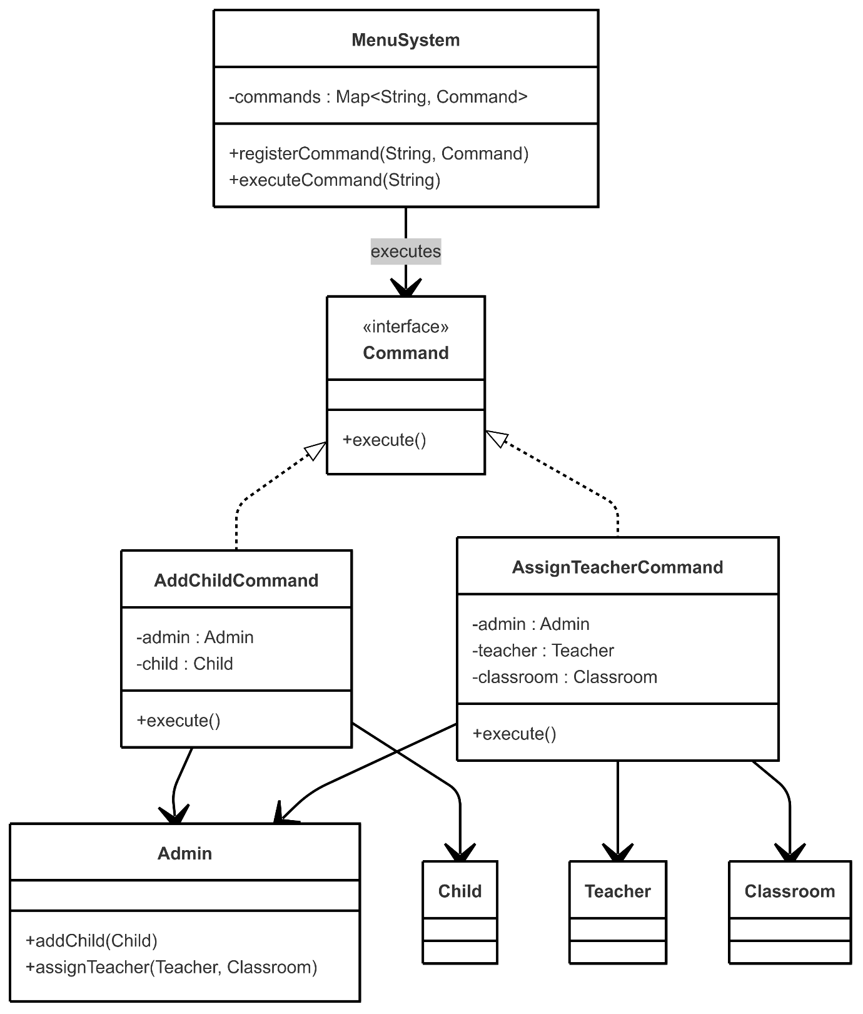

**Observer Pattern**

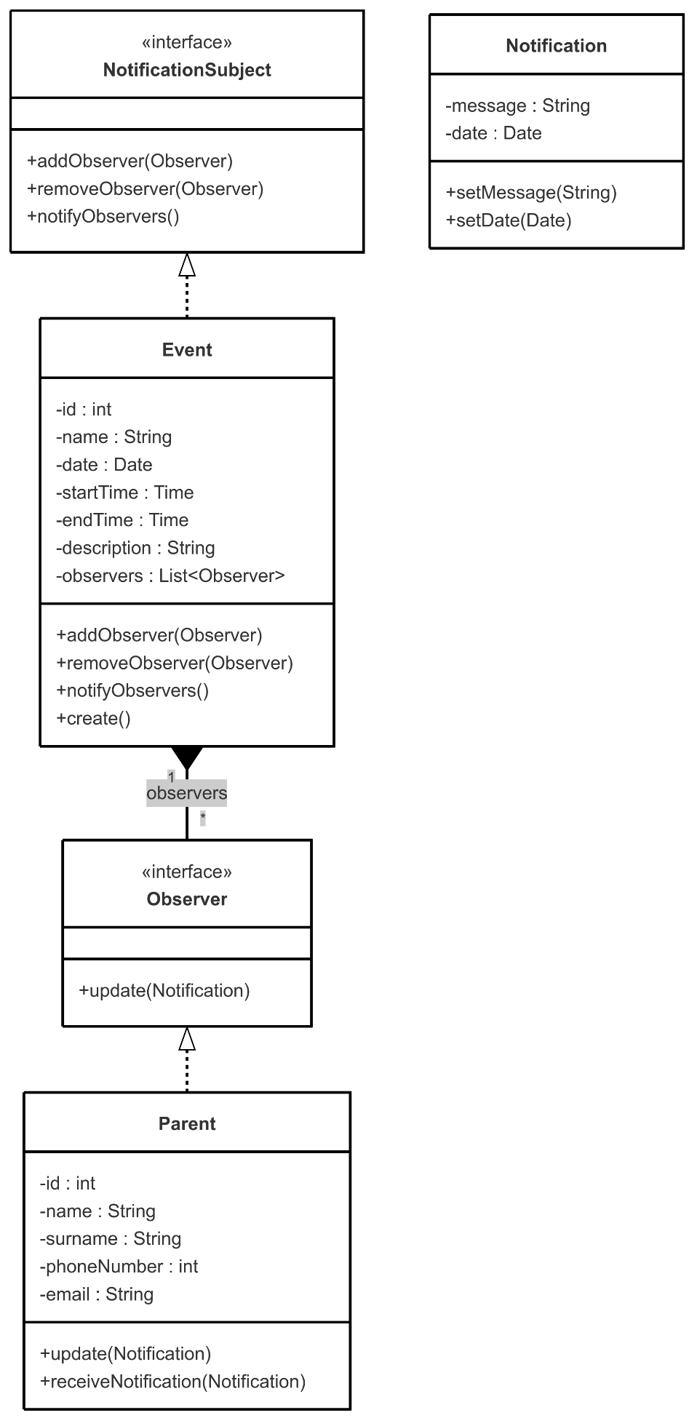

**Strategy Pattern**

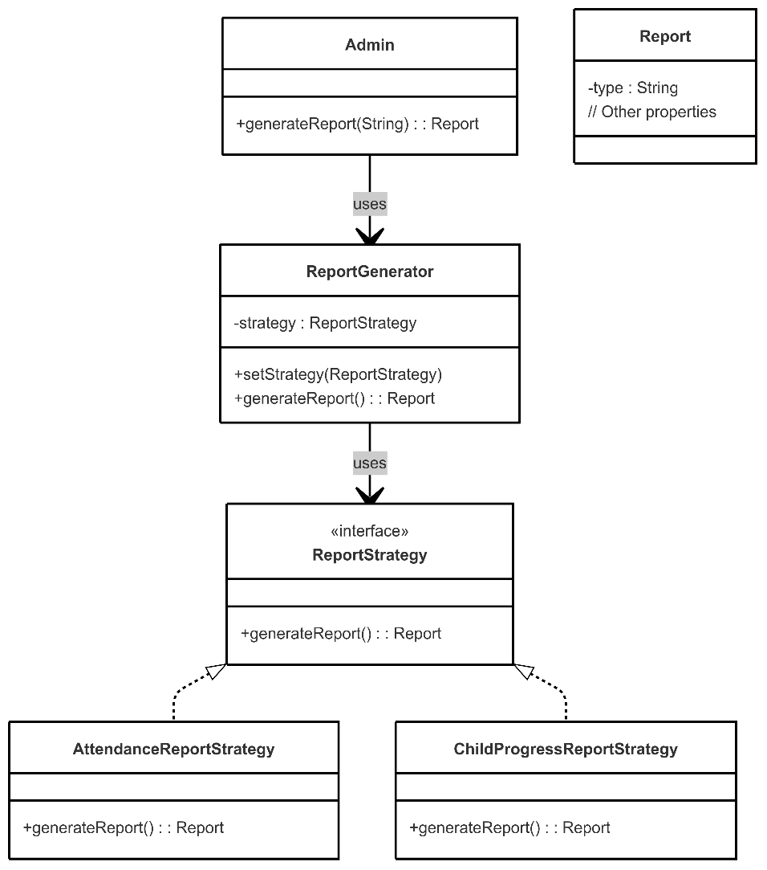

**Template Method Pattern**

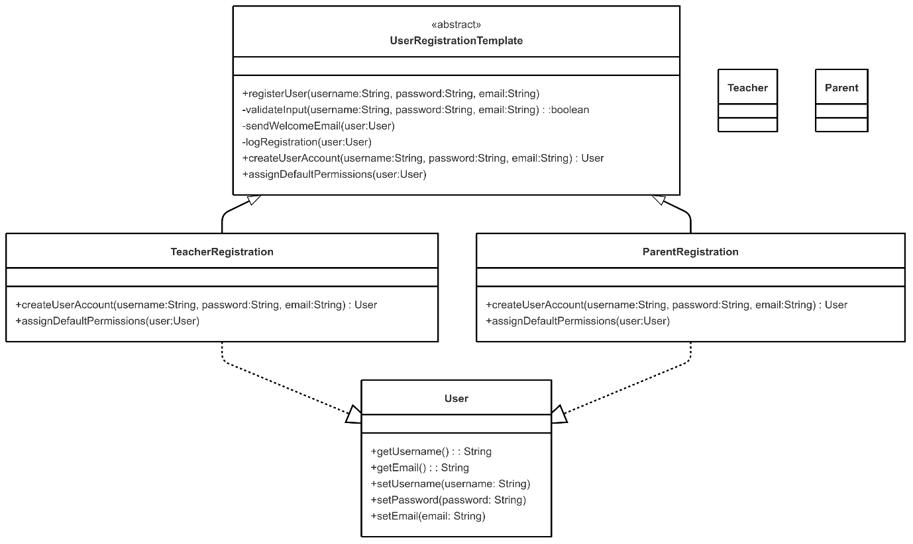

# Class Diagram

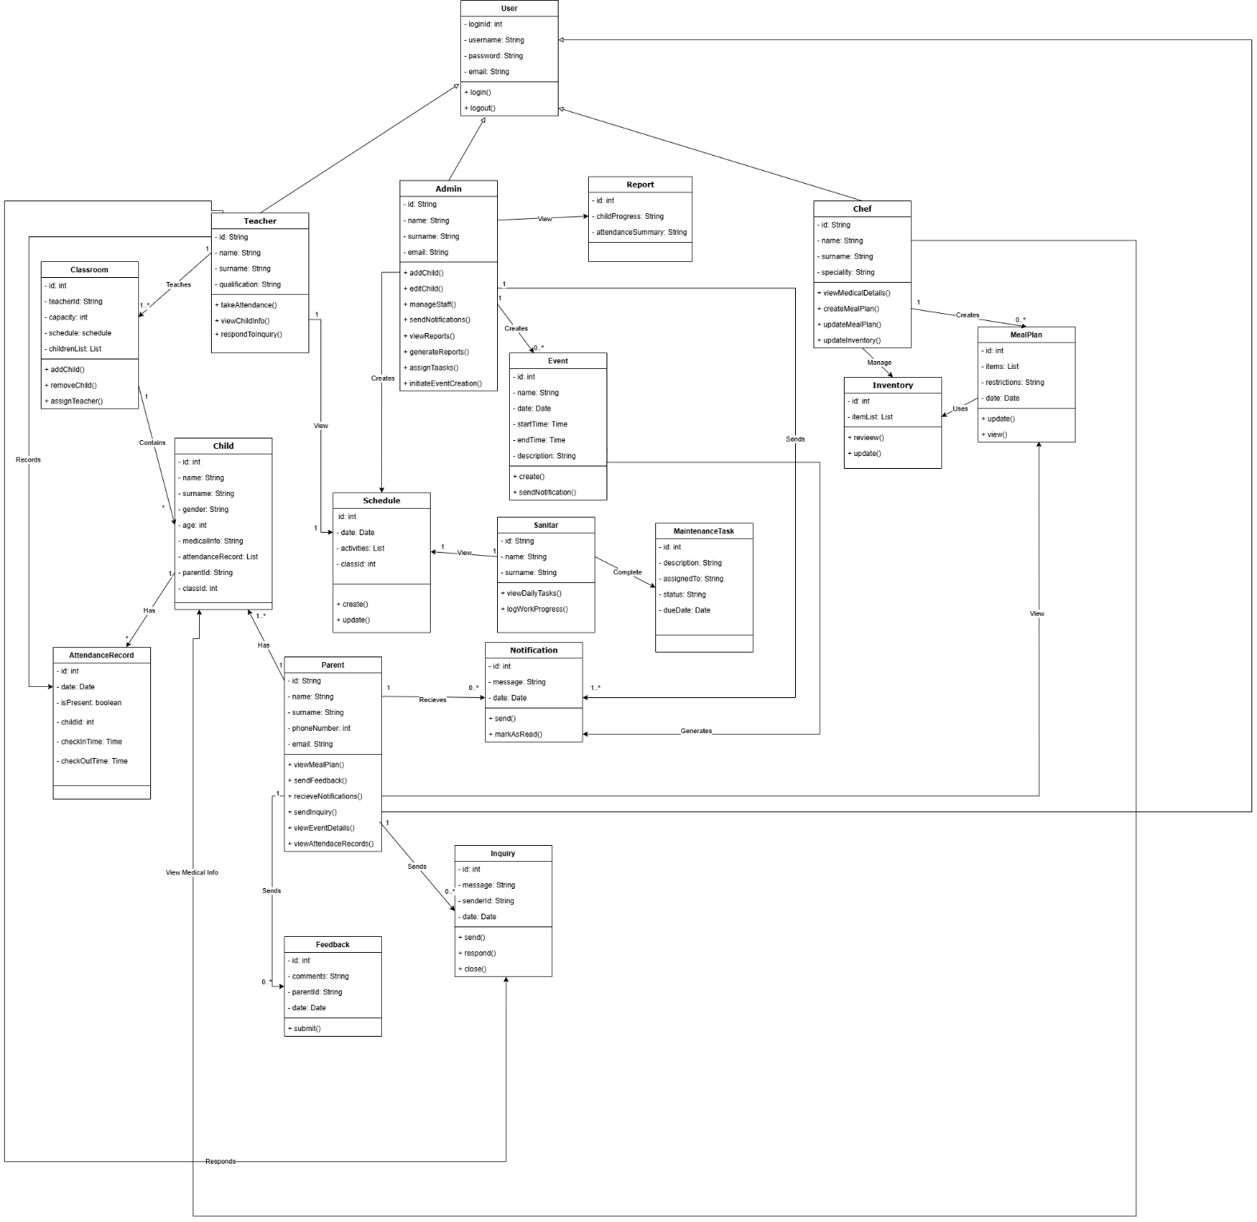

# Object Diagram

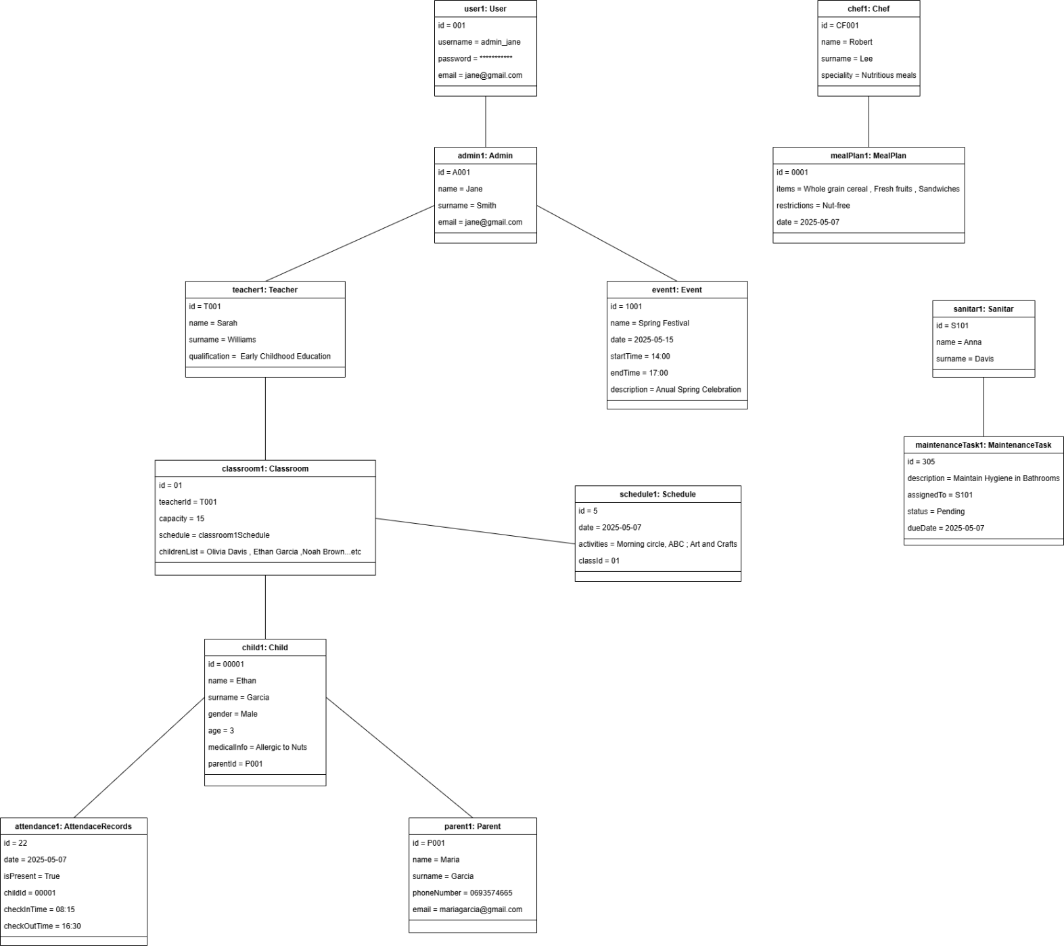

# Composite Diagram

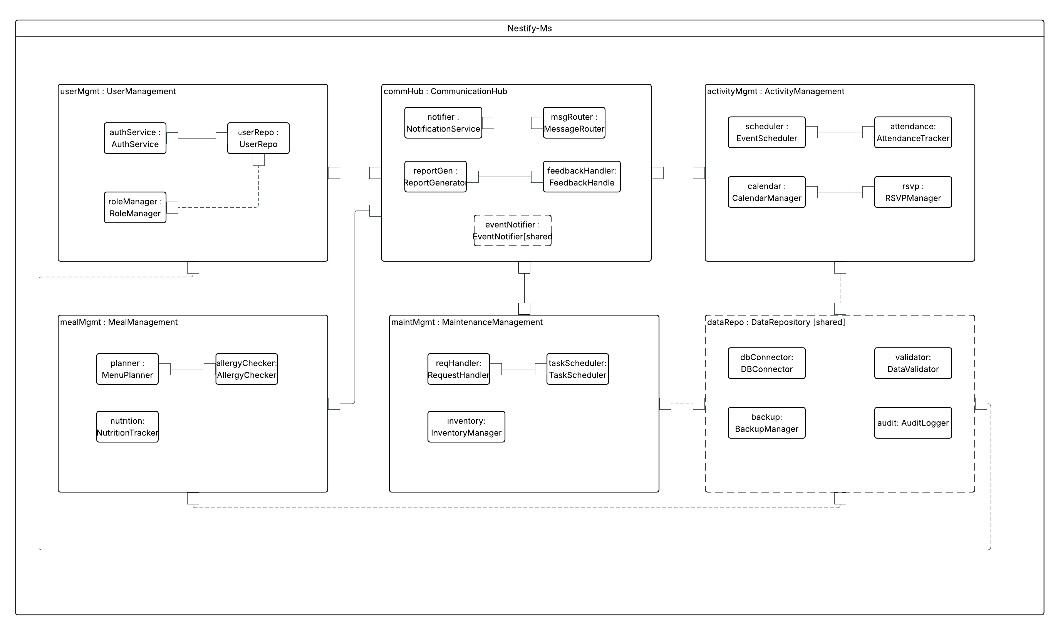

# Deployment Diagram

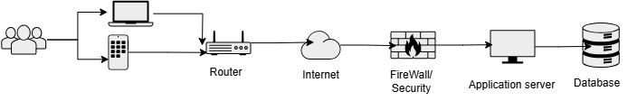

# Component Diagram

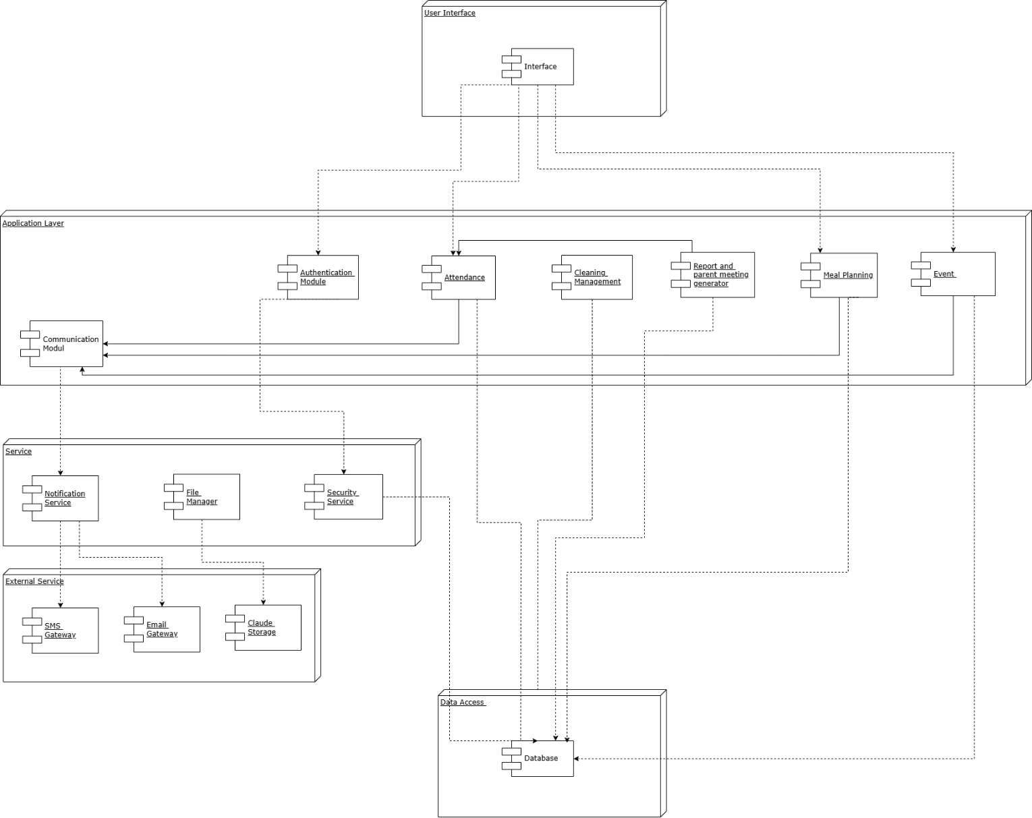

# Package Diagram

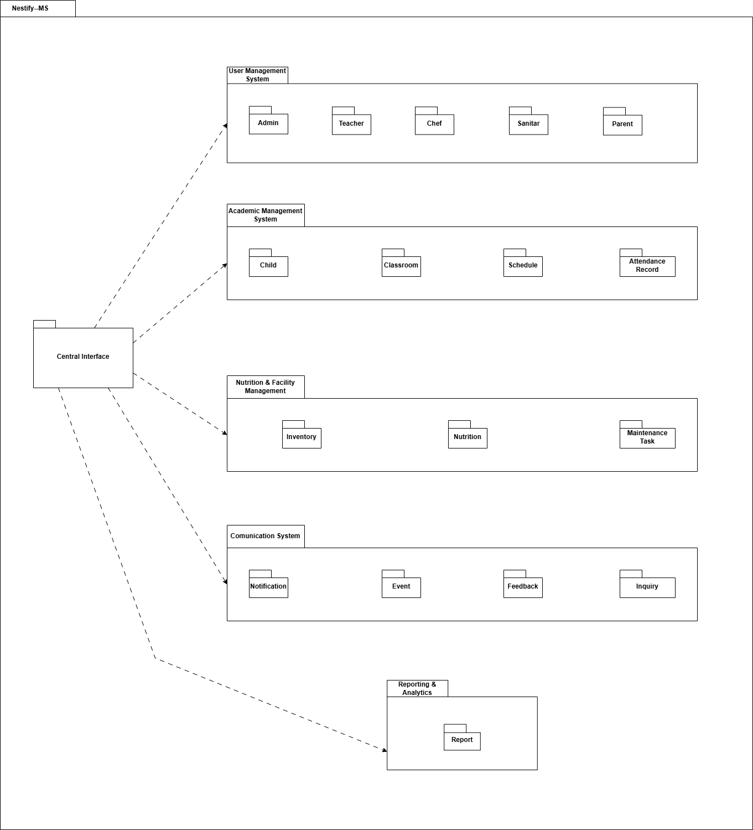

# User Interface Design

**Login Interface**

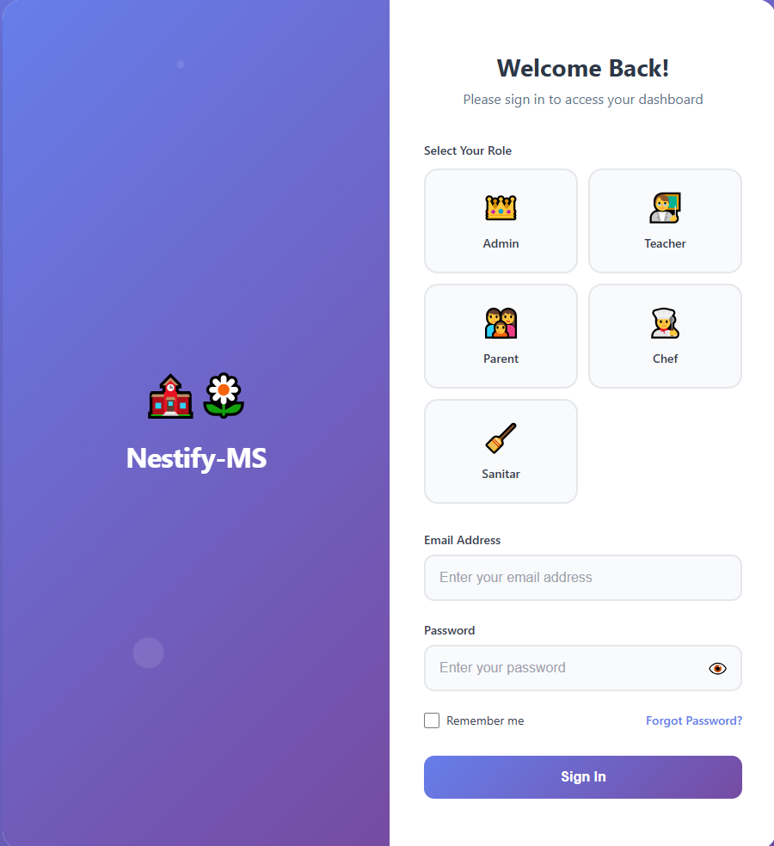

**Admin Interface**

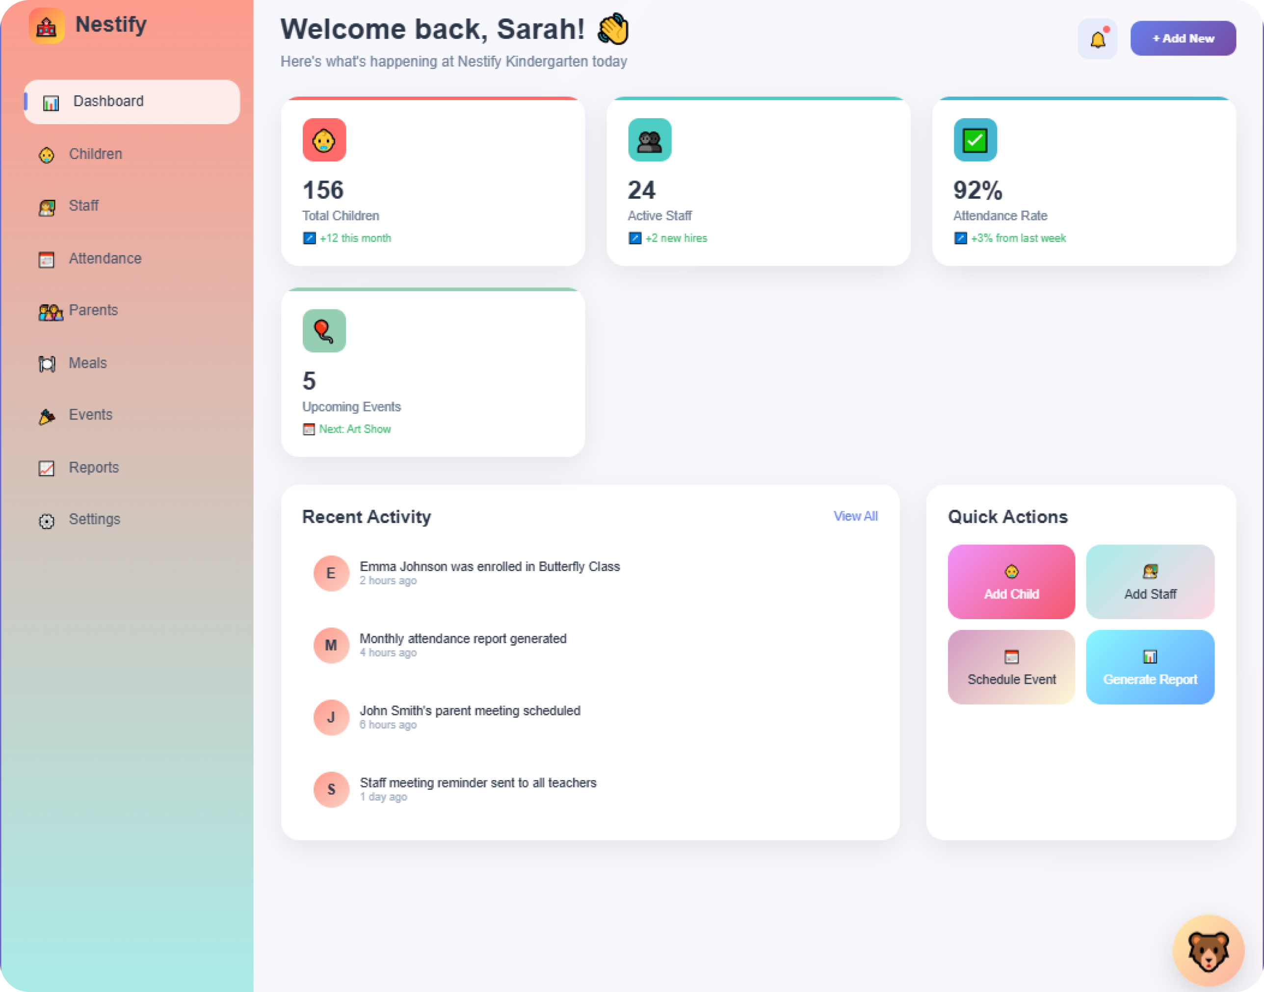

**Parent Interface**

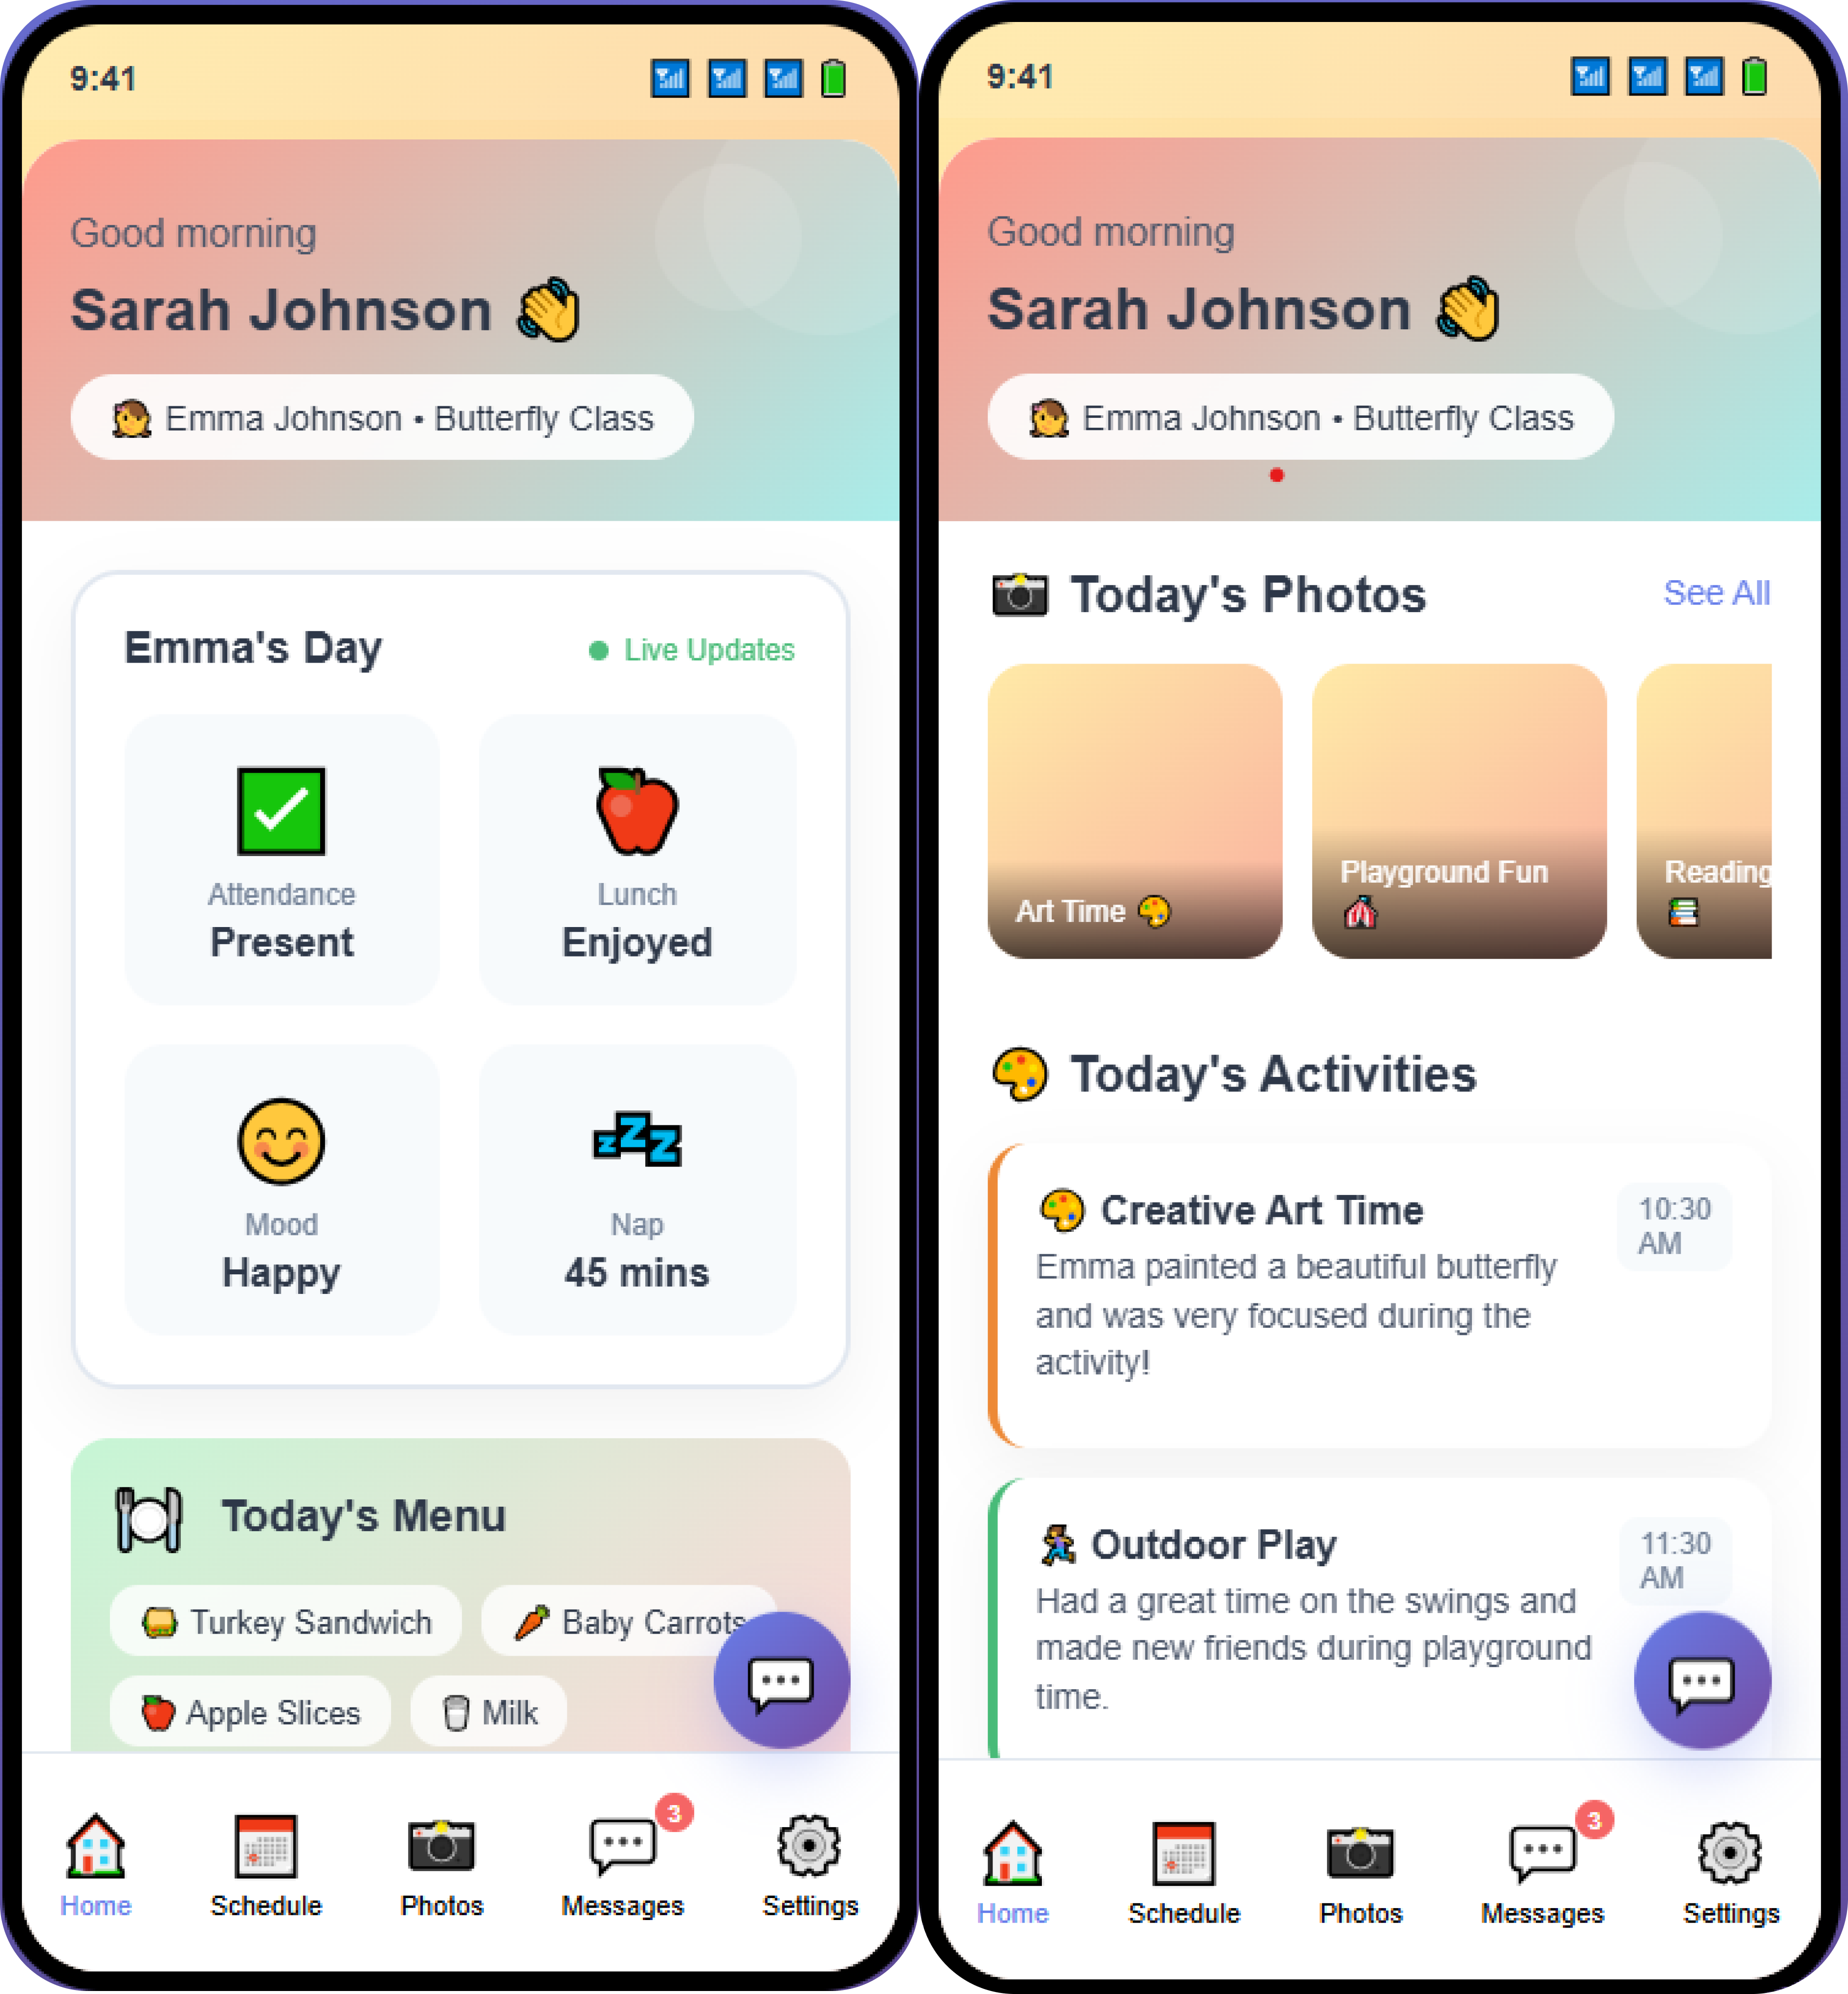

**Chef Interface**

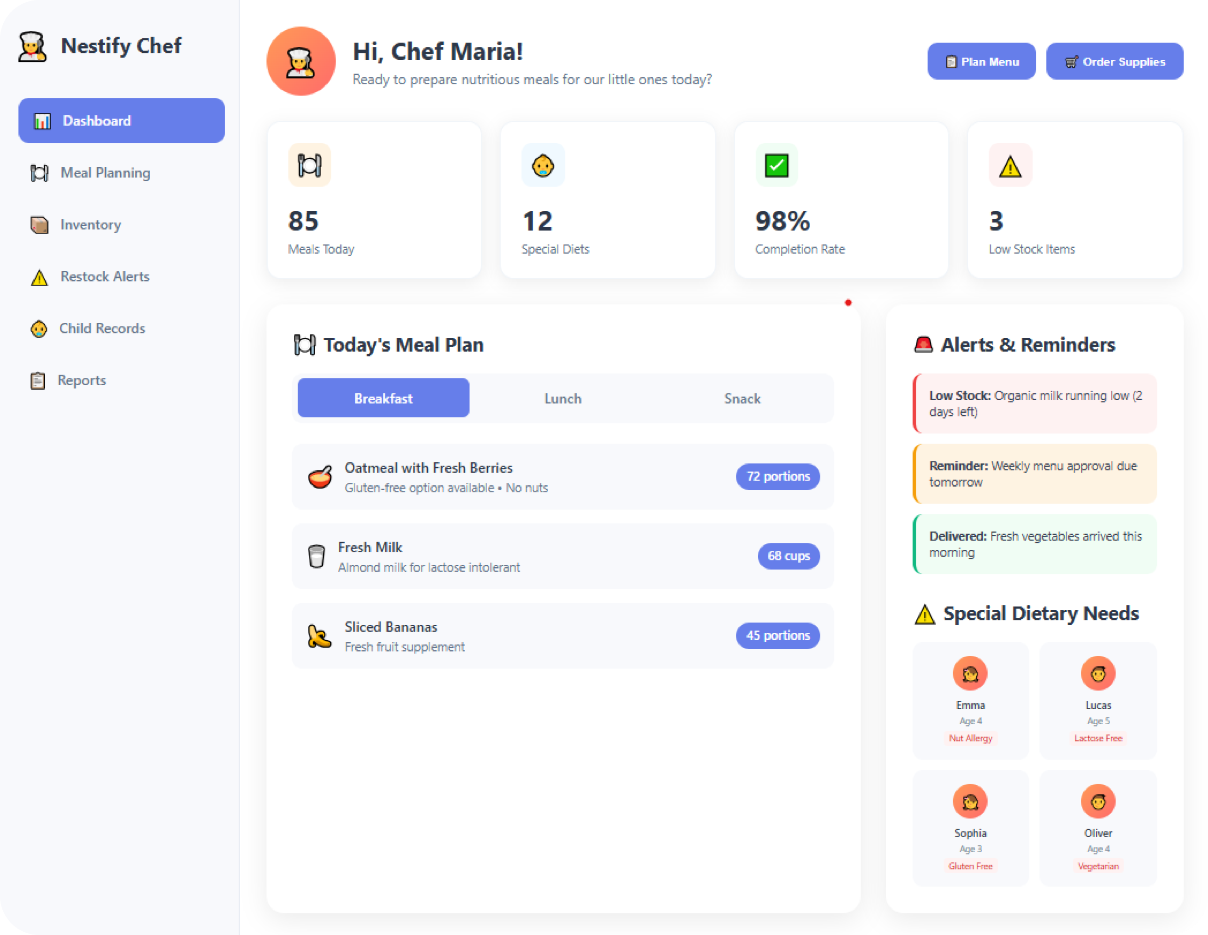

**Sanitar Interface**

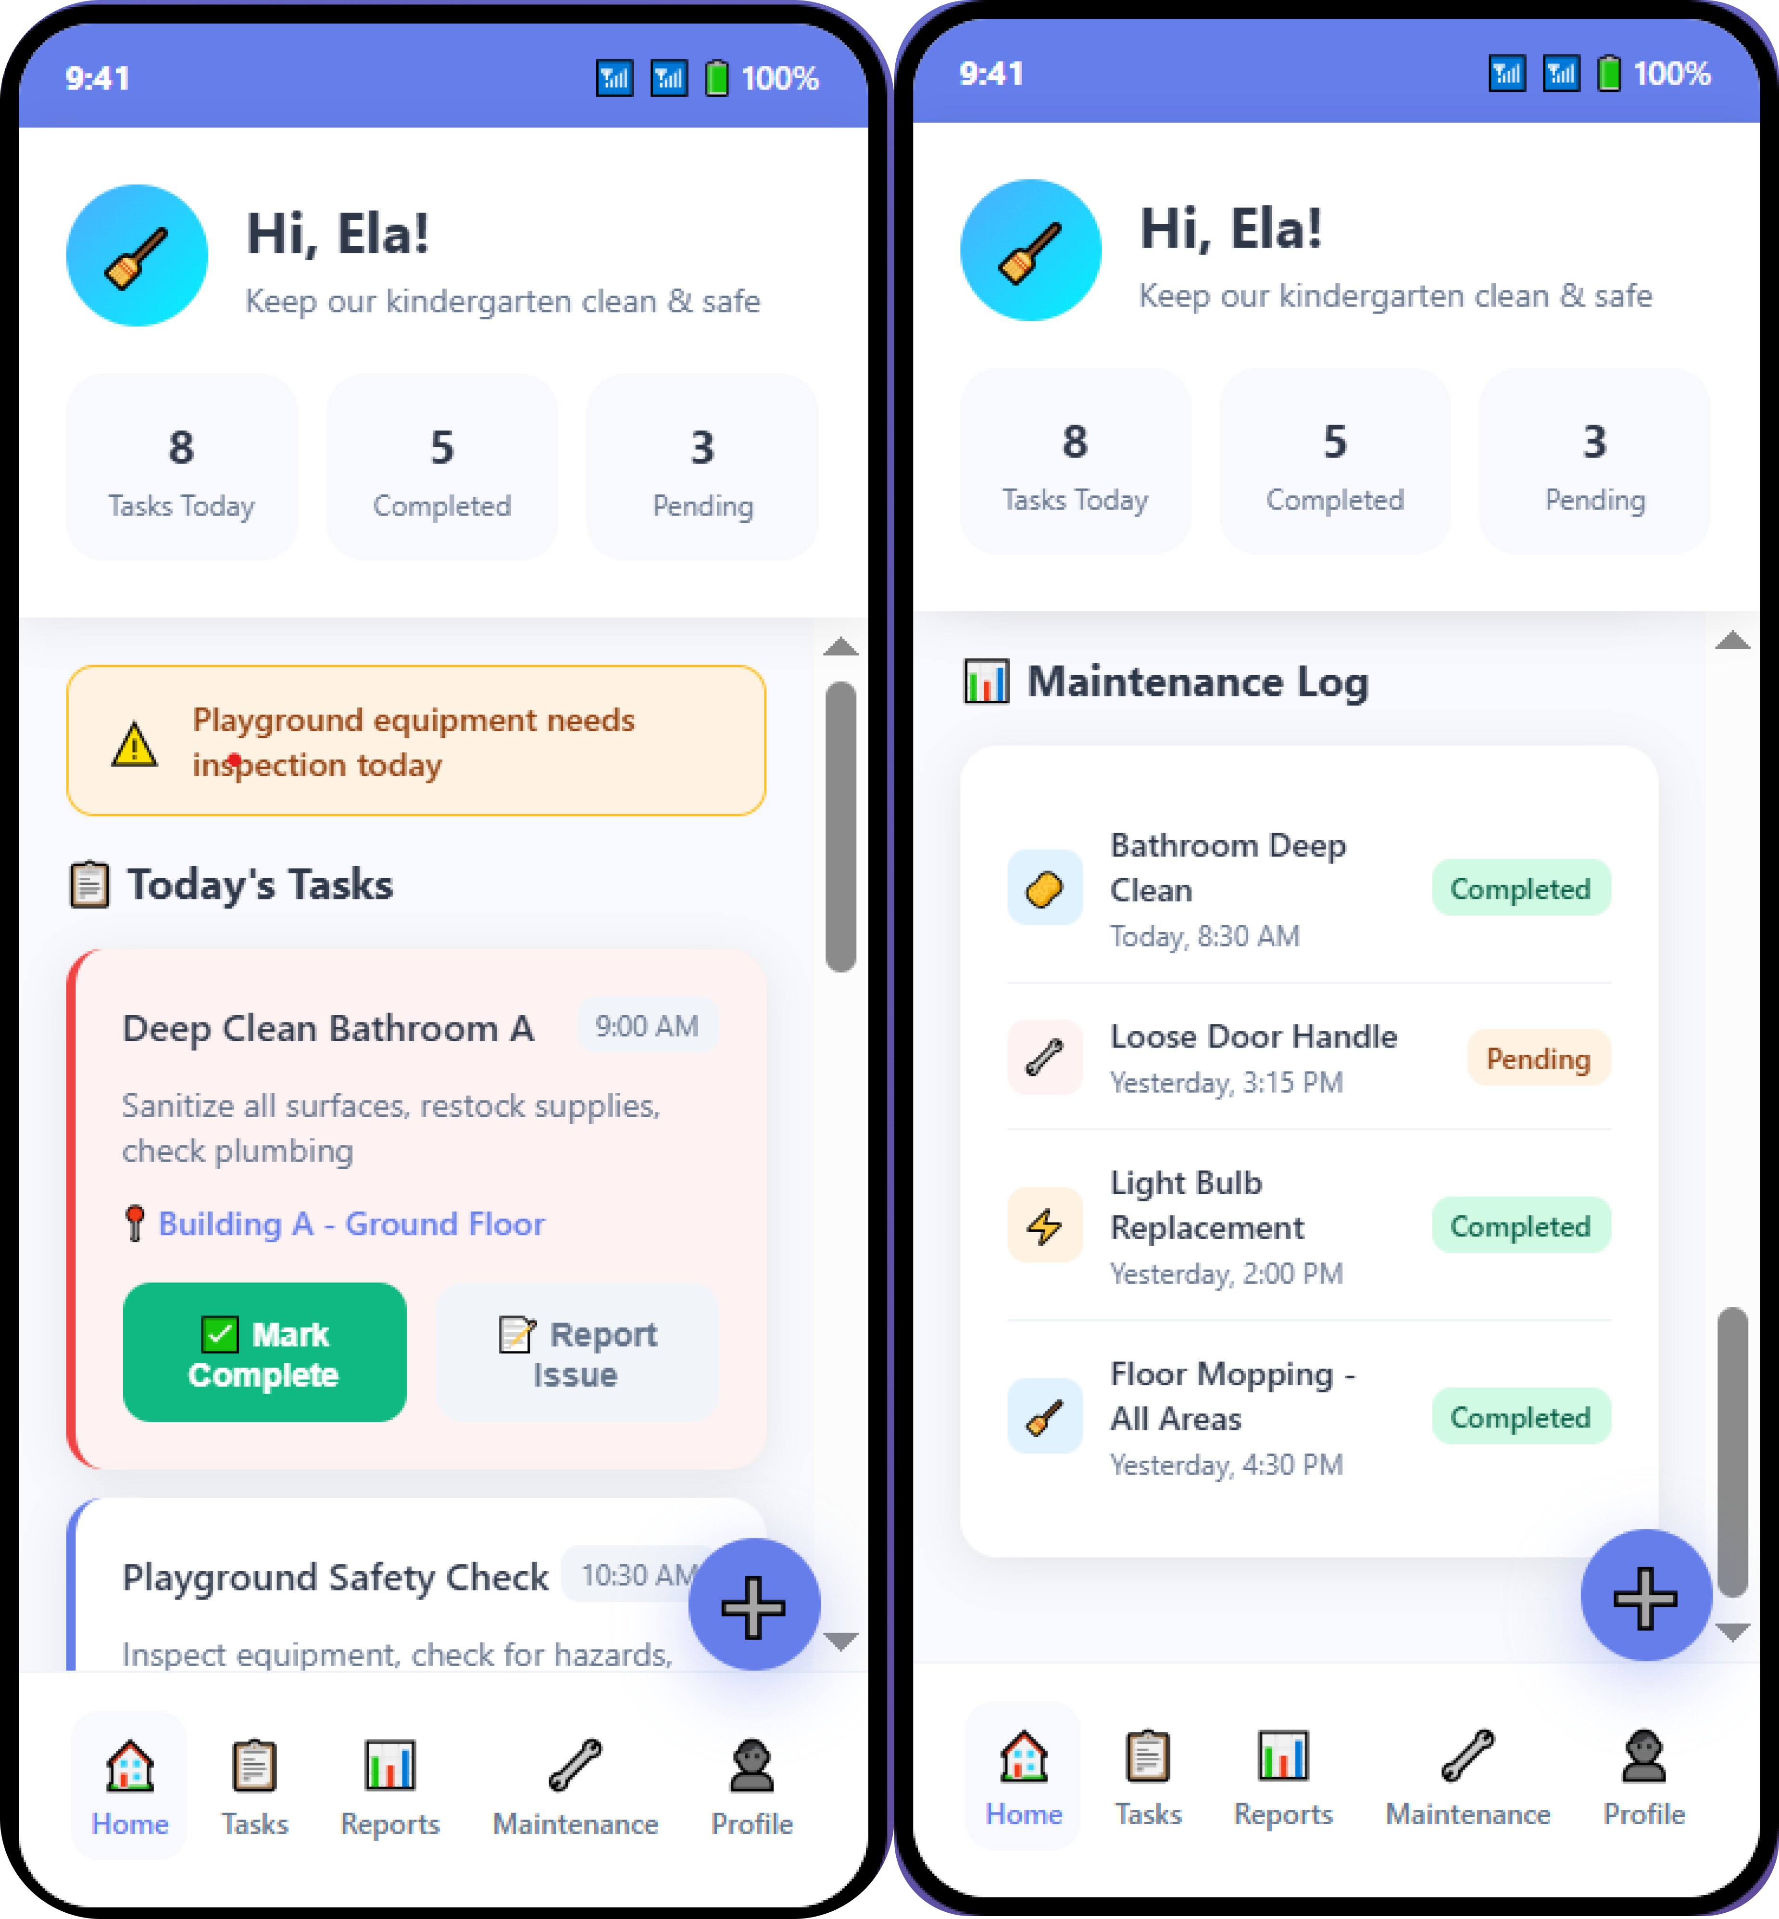

**Teacher Interface**

